Agriculture Data Collection Worksheet

What are the types and characteristics of early and current
indigenous farming practices?
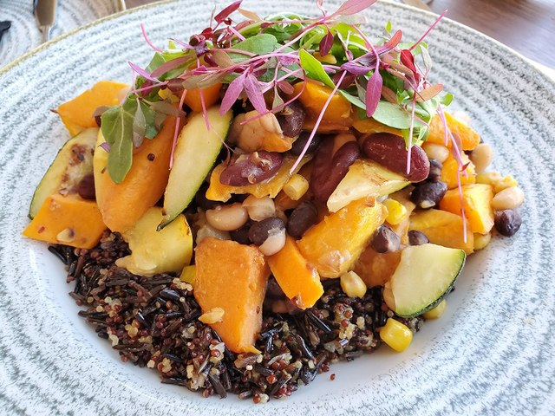

Student Names: ___________________________________________________

Type of Agriculture | Characteristics - be specific and provide examples
Polyculture
Monoculture

Image:https://commons.wikimedia.org/wiki/File:Three_Sisters_Saute_at_Thirty_Nine_Restaurant_at_First_Americans_Museum_Oklahoma_City.jpg

Agriculture Data Collection Worksheet - ANSWER KEY

What are the types and characteristics of early and current
indigenous farming practices?

Student Names: ___________________________________________________
Type of Agriculture | Characteristics - be specific and provide examples
Polyculture | Corn, beans, and squash (human consumption); tomato and basil (human consumption); rye & soybean (human consumption and livestock feed)
Monoculture | Corn (human consumption, livestock feed, and biofuel)
 | Wheat (human consumption and livestock feed)
 | Beans (human consumption and livestock feed)
 | Potatoes (human consumption)
 | Bananas, orange, apples (human consumption)
Image:https://commons.wikimedia.org/wiki/File:Three_Sisters_Saute_at_Thirty_Nine_Restaurant_at_First_Americans_Museum_Oklahoma_City.jpg

Name ___________________ Venn Diagram Worksheet

Based on your research, create a Venn Diagram showing types of agricultural methods used by indigenous people and modern and contemporary farming practices:

_______Polyculture_______ _________Monculture____________

Lesson 1 RUBRIC for Piktochart

Levels of Accomplishment | Criteria | Points
Exceeds expectations | Graphic includes extensive, detailed information pertaining to what the Three Sisters practice involves, and other types of agriculture. Graphic contains: four or more images that directly support your text; clear identification and explanation of the types of agriculture, and; clear cultural and scientific significance of the Three Sisters. | 12
Meets expectations | Graphic includes detailed information pertaining to what the Three Sisters practice involves, and other types of agriculture. Graphic contains: three images that directly support your text; clear identification and explanation of the types of agriculture, and; clear cultural and scientific significance of the Three Sisters. | 10-11
Somewhat meets expectations | Graphic includes some information pertaining to what the Three Sisters practice involves, and other types of agriculture. Graphic contains: two images that directly support your text; some identification and explanation of the types of agriculture, and; some cultural and scientific significance of the Three Sisters. | 6-9
Fails to meet expectations | Graphic includes some information pertaining to what the Three Sisters practice involves, and other types of agriculture. Graphic contains: one or no images that directly support your text; little to no identification and explanation of the types of agriculture, and; little to no cultural and scientific significance of the Three Sisters. | 0-5

