Home Water Usage Survey
Dear Families,
At this time, our class is learning about water usage and preservation. Please do your best to complete the survey by documenting your family's water usage for one day. The data collected helps our class with our upcoming Civic Action Plan that can be extended at home.

Date of Activity: ______________
Family Size: __________________

Activity | Tally | Total Per Day
Dishwashing by Hand
Dishwasher Loads
Baths Taken
Teeth Brushing
Toilet Flushes
Clothes Washing Loads
Lawn Watering
Calculations
Activity | Total Per Day | X Gallons | Total Gallons
Dishwashing by Hand |  | X 8
Dishwasher Loads |  | X 6
Baths Taken |  | X 30
Teeth Brushing |  | X 4
Toilet Flushes |  | X 1.6
Clothes Washing Loads |  | X 14

= _____________ TOTAL GALLONS

Showers
Minutes | Tally | Total
5 Minutes
10 Minutes
20 Minutes
More Than 20 Minutes
Shower Calculations
Total Number of Minutes Showering by Family = ______________ Total Minutes
Total Minutes (_____) x 2.5 gallons = _________________ Total Gallons of Water

Water Drank
Amount | Tally | Total
8 Ounces
16 Ounces
24 Ounces
32 Ounces
More Than 40 Ounces
Water Drank Calculations
Total Ounces of Water Drank by Family:_________________
(______) Total Ounces ➗ 16 = _________________ Total Gallons of Water Drank

Name:
Water Observations Worksheet

- Describe the water in your own words.

- Would you drink this water? Circle YES or NO

- Would you eat the fish and other animals that come from it? Please explain your answer.

- How do you think the colonizers treated the river?

Water Observation #2
Part A Questions:
Would you drink this water? | Yes | No
Would you swim in this water? | Yes | No

Part B Question: Explain what you think happens to the wildlife in the river.

Part C Questions:
Would you drink this water? | Yes | No
Would you swim in this water? | Yes | No

Part D Questions:
Would you drink this water? | Yes | No
Would you swim in this water? | Yes | No

In your own words, explain how Westward Expansion affected the water.

_______________________________________________________________________________
_______________________________________________________________________________

_______________________________________________________________________________
_______________________________________________________________________________

________________________________________________________________________________

Family Reflection Questions
What are other ways your family uses water?
____________________________________________________________________________________________________________________________________________________________________________________

Discuss with your family what would happen if you did not have access to clean, safe water for a day.

Name:
Date:
Water Observations Assessment
- Describe how the water changed throughout the activity. Use examples from the activity to support your answer.
_____________________________________________________________________________
_____________________________________________________________________________
_____________________________________________________________________________
_____________________________________________________________________________
_____________________________________________________________________________
_____________________________________________________________________________

- Who polluted the Colorado River? How do you know?
_____________________________________________________________________________
_____________________________________________________________________________
_____________________________________________________________________________
_____________________________________________________________________________
_____________________________________________________________________________
_____________________________________________________________________________

- In your own words, explain if it is easier to prevent pollution or to clean it up later.
_____________________________________________________________________________
_____________________________________________________________________________
_____________________________________________________________________________
_____________________________________________________________________________
_____________________________________________________________________________
_____________________________________________________________________________

Indigenous Storytelling Preface

Before colonization, Indigenous people occupied the lands that we know as present-day North America. Indigenous communities sustainably managed the lands for thousands of years. During this time, the population was very low. Native Americans lived in various subgroups across North America known as “tribes”. Indigenous people depended on the land for many things they needed to survive. The tribes used all the natural resources in every aspect of their lives. They lived simply by not changing the natural environment too much. For example, tribes created gardens and preserved what was already on the land. Eastern tribes hunted in the forests and found food in the swamps. Plain tribes scouted animals like bison and would use every part of the animal. Considering how much the bison helped the tribe, they even paid tribute to the animal through song, dance, and prayer. Present-day Indigenous people still possess the perspective of seeing the land and animals as relatives and water as sacred.

Lesson Icons

Trees

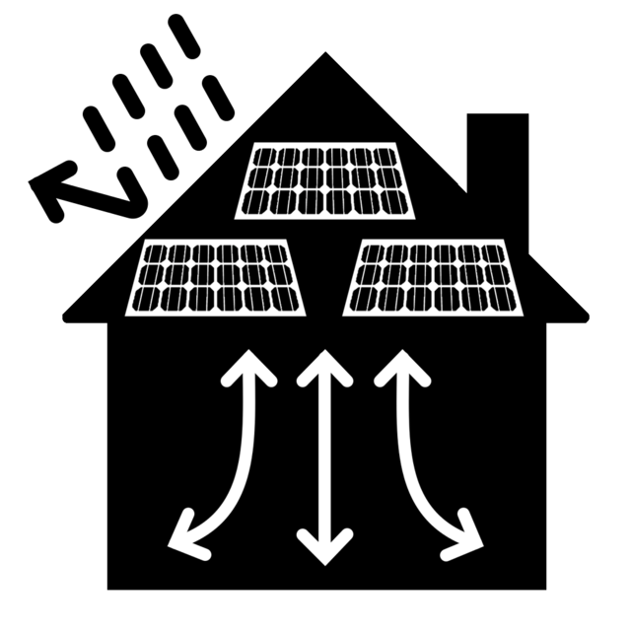
Building Site

Fishing

Family Picnics

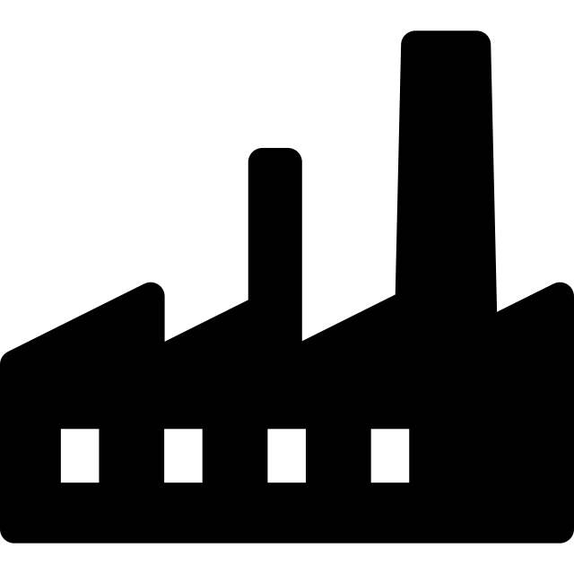
Factory

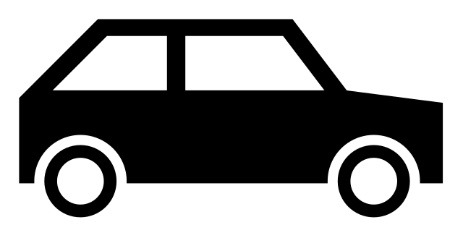
Traffic

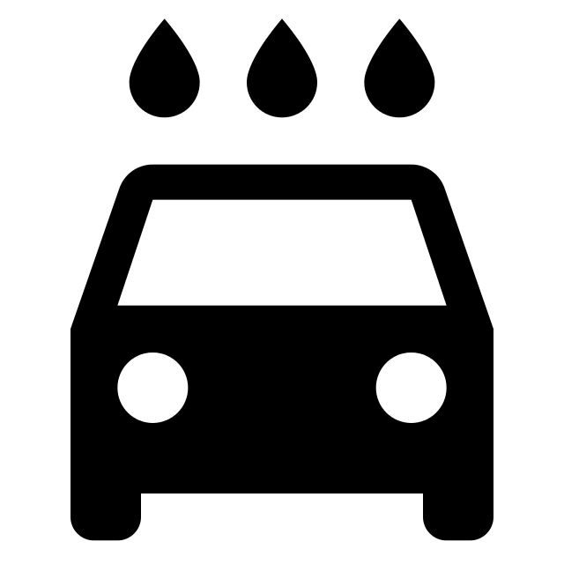
Car Wash

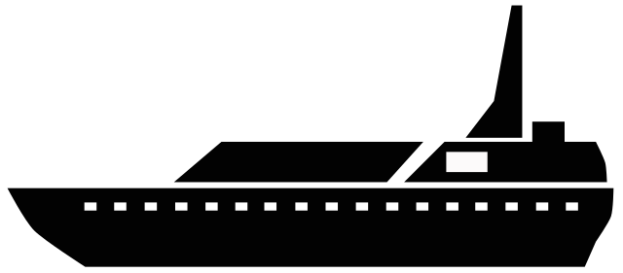
Motorboat

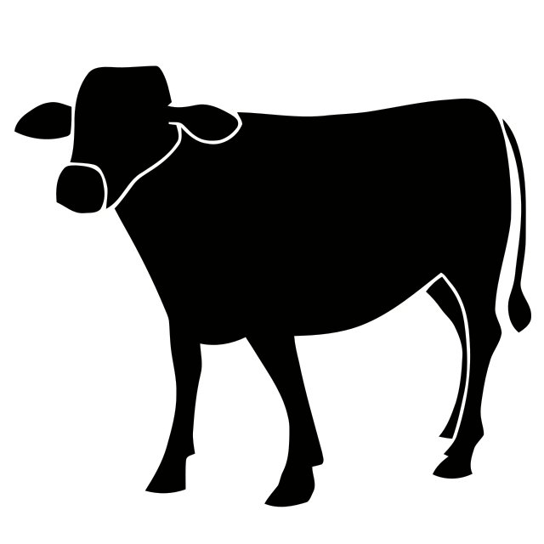
Farm/Barnyard

End of It Unit Assessment - Rubric

Task | 1  Minimally Proficient | 2  Partially Proficient | 3  Proficient | 4  Highly Proficient
Students use the key vocabulary words in their writing sample. | Students do not use the key vocabulary words in their writing sample to support their point of view. | Students use (1-2) key vocabulary words in their writing sample to support their point of view. | Students use (3) key vocabulary words in their writing sample to support their point of view. | Students use all (4) key vocabulary words in their writing sample to support their point of view.
Students use textual evidence from the We Are Water Protectors book and Who Polluted the Colorado River activity to support their points of view. | Students use only (1-2) details or examples from the text or activity to support their point of view in their writing sample. | Students use (3-4) details or examples from the text or activity to support their point of view in their writing sample. | Students use (5) details or examples from the text or activity to support their point of view in their writing sample. | Students use (6) or more details or examples from the text or activity to support their point of view in their writing sample.
Students produce a (2-3) paragraph writing sample using conventions of standard English capitalization, punctuation, and spelling. | Students have many errors in their writing samples. | Students have some errors in their writing samples. | Students have few errors in their writing samples. | Students have no errors in their writing samples.

Summative Assessment
Name:
Date:
As a society, we need oil, factories, farms, and businesses for many things. We also need water for many things. Do you agree with Nokomis that we need to take a stand and protect the water? Write 2-3 explanatory paragraphs to explain your point of view using evidence from Who Polluted the Colorado River activity, and the We Are Water Protectors book to support your answer. In addition, ensure you are writing complete sentences while using the key vocabulary words to explain whether you agree or disagree with Nokomis.
Key Vocabulary: Pollution, Sacred, Water Preservation, Steward
I agree/disagree with Nokomis that we need to protect our water because…
______________________________________________________________________________________
______________________________________________________________________________________
______________________________________________________________________________________
______________________________________________________________________________________
______________________________________________________________________________________
______________________________________________________________________________________
______________________________________________________________________________________
______________________________________________________________________________________
______________________________________________________________________________________
______________________________________________________________________________________
______________________________________________________________________________________
______________________________________________________________________________________
______________________________________________________________________________________

Vocabulary Assessment

Name:
Date:

Pollution
Definition: | Picture:

Sacred
Definition: | Picture:

Water Preservation
Definition: | Picture:

Steward
Definition: | Picture:

