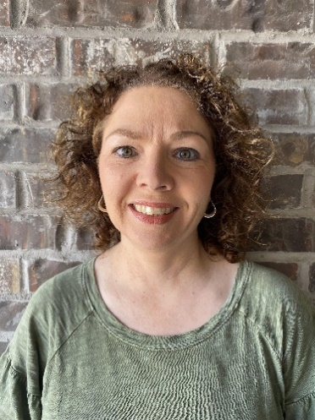
Oklahoma…
Lori Lane
Lori Lane is a 7th grade geography and science teacher at Owasso 7th Grade Center in Owasso, Oklahoma. The previous six years, she was a paraprofessional working with 7th, 8th, and 9th graders at Greenwood Junior High School, in Greenwood, Arkansas. She serves as a committee member for the National Junior Honor Society at O7GC. Her passion is teaching middle school students about the world we live in. She strives to empower students to become well-informed and active citizens who are world-changers. Lori has been married to Chance for 27 years. She enjoys traveling with her husband, attending live sporting events, and cheering on her 6 children as they participate in a variety of extracurricular activities.
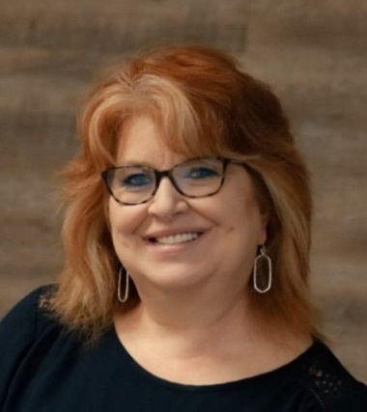
Zena Lewis
Zena Lewis has been teaching for 24 years. As a geography teacher and reading specialist, she sees geo-literacy and grant writing as an essential tool in her classroom. Lewis was selected by National Geographic Society to participate in their Summer Geo-Inquiry Institute and collaborated with educators from around the world. Opportunities like this have allowed her to teach educators about National Geographic Educator Certification, the Geo-Inquiry Process, grant writing, along with geography and literacy strategies in the classroom. She is a National Geographic Certified Educator and an Oklahoma Alliance for Geographic Education (OKAGE) Teacher Consultant. She recently was funded to produce curriculum for National Geographic Society Covid Relief Fund for Educators. Mrs. Lewis has been named as a 2021 Innovative Educator by the K20 Center She has mentored fellow educators by leading sessions in professional development opportunities. Grant writing has consistently funded resources for her innovative classroom. Zena Lewis recently earned one of her greatest career accomplishments, achieving her National Board teacher certification. Lewis now mentors’ candidates going through the process of their National Board-Certified Teacher certification. Mrs. Lewis is a 2022 Funds for Teachers Fellow and will travel this summer to engage in her proposed fellowship. She has been married to the love of her life for 33 years, has three daughters, one son-in-law, and two grand-babies who keep her busy and smiling.

