Teacher Handout: “Ranking of Personal Interests” Paper Strips
Directions: Make copies of this handout, enough for one per student. Cut each topic issue along the lines into paper strips and place inside a sealable plastic baggie. Prepare one baggie per student.
impact of climate change (rising sea levels, extreme heat) | oil/gas drilling
dams | toponyms
grazing rights | toxic/nuclear waste
land acknowledgements | water pollution
mining | younger generations living on indigenous land
national, state or public parks | zoning
Issue: _________________________________________ | Issue: _________________________________________
Issue: _________________________________________ | Issue: _________________________________________

Name______________________ Student Handout: Ranking of Personal Interests - Page 1

Directions: The 12 labeled paper strips feature contemporary issues impacting indigenous sacred lands in the United States. The 4 blank paper strips provide optional opportunities for you to draw upon outside knowledge and write any land issues that are not already listed.

Using the chart on the back of this handout, arrange the paper strips to rank them in order of “MOST important to me personally / I’m MOST interested in learning about this issue.” to “LEAST important to me personally / I’m LEAST interested in learning about this issue.” After finalizing your ranking, tape the strips into the chart.

Name_______________________ Student Handout: Ranking of Personal Interests - Page 2

 | Ranking | Paper Strips: Issues Impacting Indigenous Sacred Lands
Of Most importance to me personally. /  I’m Most interested in learning about this issue.  Of Least importance to me personally /  I’m Least interested in learning about this issue | 1
 | 2
 | 3
 | 4
 | 5
 | 6
 | 7
 | 8
 | 9
 | 10
 | 11
 | 12
 | 13
 | 14
 | 15
 | 16

Teacher Resource - “Mentimeter Word Cloud” Example

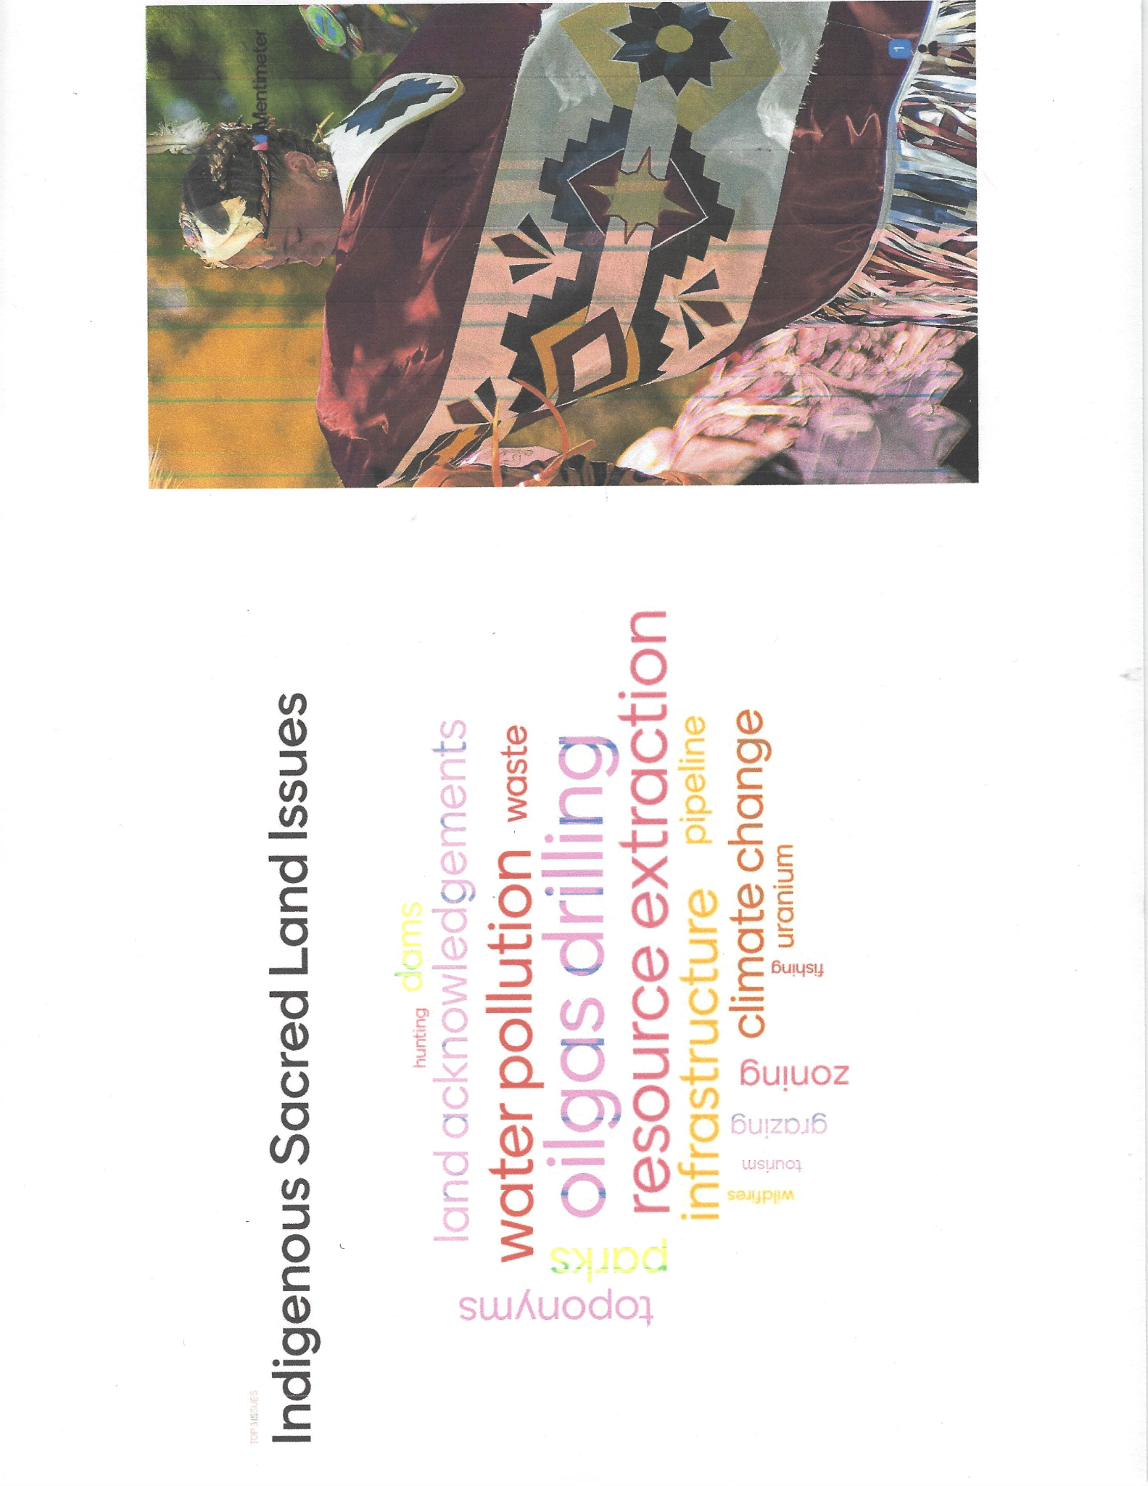

Name_____________________________Visual Vocabulary - page 1

For each vocabulary word: 1) write its definition from a dictionary, 2) rewrite the definition in your OWN words, 3) write an example of the word, and, 4) draw a visual or symbol of the word.

civic action
Definition actions or steps taken by community members to address problems or issues in their local community
Own Definition actions people take to solve problems in their community
Example 1) speaking at a city council meeting about a community safety issue
2) volunteering to tutor newly arrived refugees with English lessons
Visual

https://creativecommons.org/licenses/by-nc-sa/3.0/
infrastructure
Definition

Own Definition

Example

Visual

land acknowledgement
Definition

Own Definition

Example

Visual

land rights
Definition

Own Definition

Example

Visual

Visual Vocabulary - page 2

public land
Definition

Own Definition

Example

Visual

stakeholder
Definition

Own Definition

Example

Visual

toponym
Definition

Own Definition

Example

Visual

zoning
Definition

Own Definition

Example

Visual

Name__________________ Case Study Analysis: Mt Rushmore Controversy - Page 1
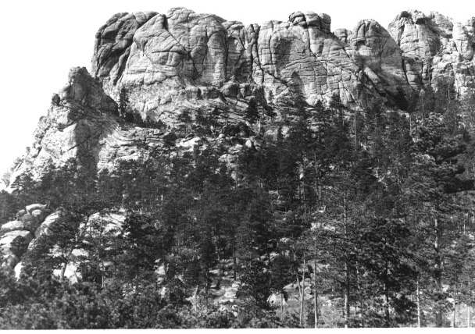

Mount Rushmore, originally known to the Lakota Sioux as Six Grandfathers, c. 1905, NPS Photo

Mount Rushmore National Memorial, located in South Dakota,
memorializes four U.S. Presidents whose faces are carved on
the granite face of a mountain in the Black Hills. Annually 2.5
million tourists visit this monument which has been praised as
the “Shrine of Democracy.” Originally known to the Lakota
Sioux as Six Grandfathers (Tȟuŋkášila Šákpe), Mount
Rushmore resides on traditional sacred lands, a place of deep
spiritual importance for 20+ tribal nations of the Great Plains.
Learning Task #1
1) View the Video: “Mount Rushmore: Carving History and Controversy”
https://www.youtube.com/watch?v=ZrlCxIJPS-M&t=14s

2) Stakeholder Chart: Working with a partner, rewatch the video
to identify the various stakeholders who claim land rights to
Mount Rushmore. Describe the supporting arguments for each
stakeholder’s claim to the land.
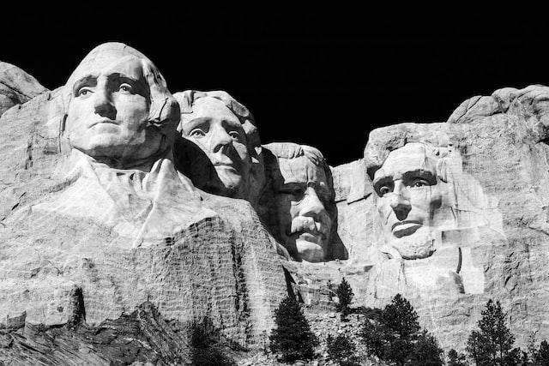
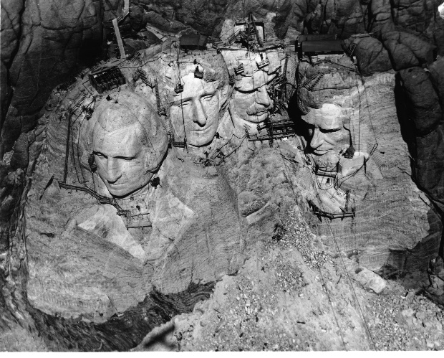

Photo by Brandon Mowinkel on Unsplash,
Mount Rushmore, 2016

Aerial view of Mount Rushmore National Memorial as it neared completion, 1940
NPS Photo
Stakeholders  (person or group) | Arguments supporting each stakeholder’s land claims

3) Reflection: Why is it important for historians to include
multiple perspectives and viewpoints on historical events?
_______________________________________________
_______________________________________________
_______________________________________________
_______________________________________________

Case Study Analysis: Mt Rushmore Controversy - Page 2
Learning Task #2 -
1) Read the PBS American Experience article: “Native Americans and Mount Rushmore.”
https://www.pbs.org/wgbh/americanexperience/features/rushmore-sioux

2) While reading the article, employ the following annotation, i.e., “marking the text” strategies:
- Number each paragraph, in the left margin. (There will be a total of 8.)
- Underline at least one challenging vocabulary word per paragraph. This word should be discussed, and its meaning clarified. Write a simplified definition in the right margin.
- Select one color to highlight key phrases showing the Native American perspective or point of view (POV) regarding land rights.
- Select another color to highlight key phrases showing the U.S. government perspective or point of view (POV) regarding land rights.
- Write additional notes and /or drawings in the right margin that reinforce vocabulary or capture the gist of the paragraph.

3) After reading and annotating the article, discuss and answer the following questions:
Paragraph #1: Why do many Native Americans see Mount Rushmore as a desecration of their sacred lands?

Paragraph #2: In 1868, the U.S. Government signed the Treaty of Fort Laramie with the Sioux people, establishing the Great Sioux Reservation (including the sacred Black Hills) to be set aside
for the exclusive use of the Sioux nations.
* How did the U.S. Government violate the terms of this treaty?

* How did the treaty violation impact the Sioux people?

Paragraph #3: In 1873, President Ulysses S. Grant stated that he favored a humane course to bring Native Americans “under the benign influences of education and civilization. It is either this or war of extermination.” Based upon his quote, what ultimatum is Grant giving to Native Americans?

Paragraph #4: What actions did the federal government take in response to General Custer’s defeat at the Battle of Little Bighorn?

Paragraph #5: How was the 1890 Battle of Wounded Knee more of a massacre than a battle?

Paragraph #6: Why was the original proposal for Mount Rushmore’s sculptures switched?

Had the original proposal to sculpt both Native American and pioneer heroes of the American West occurred, would that change the Mount Rushmore controversy?

Paragraph #7: Tribal sovereignty is the authority of an indigenous tribe to self-govern. Explain how the THREE arguments given by the Sioux people connect to their tribal sovereignty.

Paragraph #8: Does the Black Hills sculpture honoring the great Sioux chief, Crazy Horse, adequately address the Mount Rushmore controversy? Why or why not?

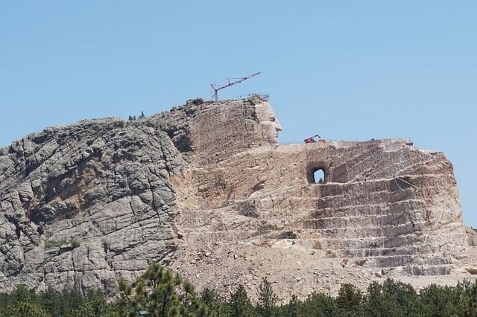

Crazy Horse Memorial, Image by Ravi Krishnappa from Pixabay, 2018

Case Study Analysis: Mt Rushmore Controversy - Page 4

Reflection: What responsibility does the U.S. government have to honor, preserve, and protect Six Grandfathers, the indigenous sacred place of the Sioux people?

What do you propose as a fair and equitable solution to the Mount Rushmore / Six Grandfathers controversy?

Resource List for a deeper dive into the history and status of the Mount Rushmore controversy:

National Park Service: Mount Rushmore National Memorial, South Dakota

https://www.nps.gov/moru/index.htm

Crazy Horse Memorial https://crazyhorsememorial.org/

National Archives: Treaty of Fort Laramie 1868

https://www.archives.gov/milestone-documents/fort-laramie-treaty
- National Geographic: “The Heartbreaking, Controversial History of Mount Rushmore” Oct 28, 2020
https://www.nationalgeographic.com/travel/article/the-strange-and-controversial-history-of-mount-rushmore
- History.com: “Why Native Americans Have Protested Mount Rushmore” Nov 18, 2020
https://www.history.com/news/mount-rushmore-native-american-protests

Cultural Survival: “We Walk on our Ancestors: The Sacredness of the Black Hills” March 10, 2014

https://www.culturalsurvival.org/publications/cultural-survival-quarterly/we-walk-our-ancestors-sacredness-black-hills

Native Hope Blog: “The Six Grandfathers Before it was known as Mount Rushmore” July 4, 2020 https://blog.nativehope.org/six-grandfathers-before-it-was-known-as-mount-rushmore

Eos Science Magazine: “Mount Rushmore’s Six Grandfathers and Four Presidents” Sept 3, 2020
https://eos.org/features/mount-rushmores-six-grandfathers-and-four-presidents

Name___________________________ Marking the Text

Directions:
1) Number each paragraph in the left margin.
2) Underline at least one challenging vocabulary word in the paragraph.
3) Write a simplified definition in the right margin.
4) Select one color to highlight phrases showing the Native American POV regarding land rights.
5) Select another color to highlight phrases showing the U.S. government POV regarding land rights.
6) Write additional notes and/or drawings in the Right margin that occur during discussion or further inquiry.

 | PBS American Experience  People & Events: “Native Americans and Mount Rushmore”  https://www.pbs.org/wgbh/americanexperience/features/rushmore-sioux/ | Notes and Definitions
 | The creation of Mount Rushmore is a story of struggle -- and to some, desecration. The Black Hills are sacred to the Lakota Sioux, the original occupants of the area when white settlers arrived. For some, the four presidents carved in the hill are not without negative symbolism. The Sioux have never had much luck dealing with white men.
 | In the Treaty of 1868, the U.S. government promised the Sioux territory that included the Black Hills in perpetuity. Perpetuity lasted only until gold was found in the mountains and prospectors migrated there in the 1870s. The federal government then forced the Sioux to relinquish the Black Hills portion of their reservation.
 | These events fit the pattern of the late nineteenth century, a time of nearly constant conflict between the American government and Plains Indians. At his second presidential inauguration in 1873, Ulysses S. Grant reflected the attitudes of many whites when he said he favored a humane course to bring Native Americans "under the benign influences of education and civilization. It is either this or war of extermination." Many of the land's original occupants did not choose to assimilate; for them war was the only option.
 | In South Dakota, Sitting Bull and Crazy Horse led various Sioux tribes against the U.S. Army. They had a notable success against General George Armstrong Custer and his troops, but the army's defeat at the Battle of Little Bighorn in America's centennial year, 1876, would cause the federal government to redouble its efforts. (Some of the area in which Rushmore stands was eventually purchased by the state of South Dakota and developed as Custer State Park; the rest was part of the Black Hills National Forest.) South Dakota was also the site of the last major defeat of Native Americans at the Battle of Wounded Knee in 1890.
In his bestselling 1970 history of Native Americans' experiences in the West, Bury My Heart at Wounded Knee, Dee Brown explains that the "battle" was actually a massacre where hundreds of unarmed Sioux women, children, and men were shot and killed by U.S. troops. The history of Wounded Knee would spur American Indian Movement (A.I.M.) activists to occupy the site in 1973. They demanded the federal government honor the treaties made with various tribes. The FBI became involved in what became known as the Second Siege at Wounded Knee, and a tense standoff resulted in the death of two Native Americans and injury to others on both sides. Violence continued to erupt for several years, including a June 26, 1975 firefight on the Pine Ridge Reservation
in South Dakota that ended with the death of two FBI agents and one Native American. In a case that continues to spur controversy, A.I.M. member Leonard Peltier was convicted of killing the FBI agents and sentenced to two consecutive life sentences in prison.

In 1927, with a history of turmoil as a background, a white man living in
Connecticut came into the Black Hills and dynamited and drilled the faces of four white men onto Mount Rushmore. At the outset of the project, Gutzon Borglum had persuaded South Dakota state historian Doane Robinson the presidents would give the work national significance, rejecting Robinson's initial suggestion that the sculpture honor the West's greatest heroes, both Native Americans and pioneers.
The insult of Rushmore to some Sioux is at least three-fold:
1. It was built on land the government took from them.
2. The Black Hills in particular are considered sacred ground.
3. The monument celebrates the European settlers who killed so many Native
Americans and appropriated their land.
 | To counter the white faces of Rushmore, in 1939 Sioux Chief Henry Standing Bear invited sculptor Korczak Ziolkowski, who worked briefly at Rushmore, to carve a memorial to the Sioux nation in the Black Hills. Perhaps wary of Borglum's troubles with financial administrators, Ziolkowski personally bought a mountain top with a granite ridge and financed the entire project privately. The statue, envisioned as a freestanding sculpture of the great Sioux chief Crazy Horse, will be much larger than any of the Rushmore figures. Korczak Ziolkowski died in 1982, but his family continues to work on this awesome undertaking; Crazy Horse's face was completed and dedicated in 1998. Although the subject of this work addresses one aspect of Rushmore's offenses, the land is still considered Sioux property, and the mountain that the Ziolkowskis are carving is still sacred. The Crazy Horse monument is not without its own dissenters and critics.

Marking the Text - Answer Key
**Answer Key (selected vocabulary and highlighted phrases may vary)
 | PBS American Experience  People & Events: “Native Americans and Mount Rushmore”  https://www.pbs.org/wgbh/americanexperience/features/rushmore-sioux | Notes &  Definitions
1 | The creation of Mount Rushmore is a story of struggle—and to some, desecration. The Black Hills are sacred to the Lakota Sioux, the original occupant of the area when white settlers arrived. For some, the four presidents carved in the hill are not without negative symbolism. The Sioux have never had much luck dealing with white men. | desecration = to treat a place with disrespect
2 | In the Treaty of 1868, the U.S. government promised the Sioux territory that included the Black Hills in perpetuity. Perpetuity lasted only until gold was found in the mountains and prospectors migrated there in the 1870s. The federal government then forced the Sioux to relinquish the Black Hills portion of their reservation. | perpetuity = for all time; forever
3 | These events fit the pattern of the late nineteenth century, a time of nearly constant conflict between the American government and Plains Indians. At his second presidential inauguration in 1873, Ulysses S. Grant reflected the attitudes of many whites when he said he favored a humane course to bring Native Americans "under the benign influences of education and civilization. It is either this or war of extermination." Many of the land's original occupants did not choose to assimilate; for them war was the only option | assimilate = to conform to the dominate culture
4 | In South Dakota, Sitting Bull and Crazy Horse led various Sioux tribes against the U.S. Army. They had a notable success against General George Armstrong Custer and his troops, but the army's defeat at the Battle of Little Bighorn in America's centennial year, 1876, would cause the federal government to redouble its efforts. (Some of the area in which Rushmore stands was eventually purchased by the state of South Dakota and developed as Custer State Park; the rest was part of the Black Hills National Forest.) South Dakota was also the site of the last major defeat of Native Americans at the Battle of Wounded Knee in 1890. | redouble = to make even stronger than before  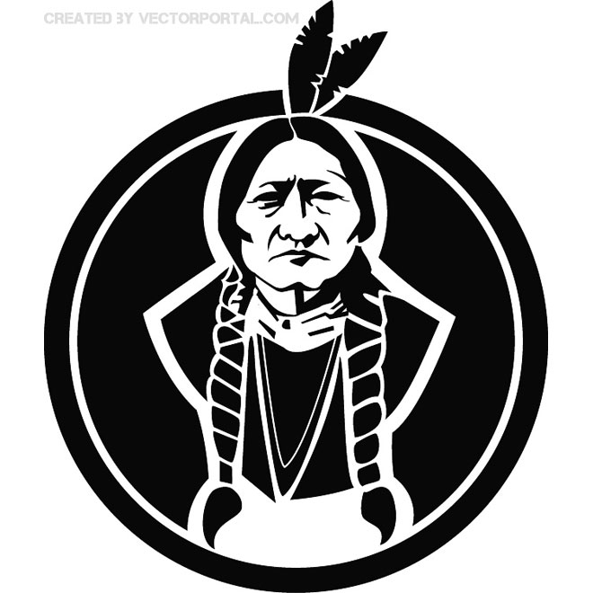
5 | In his bestselling 1970 history of Native Americans' experiences in the West, Bury My Heart at Wounded Knee, Dee Brown explains that the "battle" was actually a massacre where hundreds of unarmed Sioux women, children, and men were shot and killed by U.S. troops. The history of Wounded Knee would spur American Indian Movement (A.I.M.) activists to occupy the site in 1973. They demanded the federal government honor the treaties made with various tribes. The FBI became involved in what became known as the Second Siege at Wounded Knee, and a tense standoff resulted in the death of two Native Americans and injury to others on both sides. Violence continued to erupt for several years, including a June 26, 1975 firefight on the Pine Ridge Reservation in South Dakota that ended with the death of two FBI agents and one Native American. In a case that continues to spur controversy, A.I.M. member Leonard Peltier was convicted of killing the FBI agents and sentenced to two consecutive life sentences in prison. | massacre = to kill a large number of people in a brutal manner man  In 1990, Congress apologized to descendants of the Wounded Knee massacre.
6 | In 1927, with a history of turmoil as a background, a white man living in  Connecticut came into the Black Hills and dynamited and drilled the faces of four white men onto Mount Rushmore. At the outset of the project, Gutzon Borglum had persuaded South Dakota state historian Doane Robinson the presidents would give the work national significance, rejecting Robinson's initial suggestion that the sculpture honor the West's greatest heroes, both Native Americans and pioneers. | turmoil = violence  G Washington  T Jefferson  T Roosevelt  A Lincoln  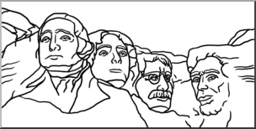
7 | The insult of Rushmore to some Sioux is at least three-fold:  1. It was built on land the government took from them.  2. The Black Hills in particular are considered sacred ground.  3. The monument celebrates the European settlers who killed so many Native Americans and appropriated their land. | appropriated = to steal or seize
8 | To counter the white faces of Rushmore, in 1939 Sioux Chief Henry Standing Bear invited sculptor Korczak Ziolkowski, who worked briefly at Rushmore, to carve a memorial to the Sioux nation in the Black Hills. Perhaps wary of Borglum's troubles with financial administrators, Ziolkowski personally bought a mountain top with a granite ridge and financed the entire project privately. The statue, envisioned as a freestanding sculpture of the great Sioux chief Crazy Horse, will be much larger than any of the Rushmore figures. Korczak Ziolkowski died in 1982, but his family continues to work on this awesome undertaking; Crazy Horse's face was completed and dedicated in 1998. Although the subject of this work addresses one aspect of Rushmore's offenses, the land is still considered Sioux property, and the mountain that the Ziolkowskis are carving is still sacred. The Crazy Horse monument is not without its own dissenters and critics. | dissenters =  individuals who disagree or take an opposing view  Crazy Horse Memorial Foundation Mission  -protect/ preserve culture of North American Indians  Unfinished carving of Crazy Horse is the world's largest sculpture.

Citations for Clipart Used on Answer Key

- Desecration | https://www.deviantart.com/danferos123/art/Desecration-519019527
- Perpetuity | https://static.vecteezy.com/system/resources/previews/004/791/158/original/infinity-forever-symbol-free-vector.jpg
- Assimilate | http://clipart-library.com/clipart/235908.htm
- Sitting Bull | https://vectorportal.com/vector/sitting-bull-indian-chief-vector.ai/11137
- Wounded Knee Patch | “AIM / Remember Wounded Knee patch,” Digital Public Library of America, https://dp.la/item/77f921b55dfe39642ca20ee993a41fc7.
- Mt Rushmore B&W | https://www.abcteach.com/resource/clip-art-mt-rushmore-bw/
- Black Hills | https://www.shutterstock.com/image-vector/black-hills-south-dakota-mountain-260nw-1603695331.jpg

Name__________________________ Philosophical Chairs: Pre-Discussion Organizer

Directions:1) Record the Topic Statement to be discussed. 2) List as many reasons as possible for why an individual might Agree or Disagree with the statement. 3) After consideration of all these reasons, summarize your CURRENT position on the Topic Statement. Use complete sentences.

Topic Statement:

Agree | Disagree
Summarize your CURRENT position on the Topic Statement:

Philosophical Chairs: Rules of Engagement
Rule #1 Make sure you UNDERSTAND the topic statement before you decide if you agree or disagree.
Rule #2 Actively LISTEN to the person speaking. Refrain from having side conversations.
Rule #3 Wait for the moderator to recognize you BEFORE you speak. ONE speaker at a time, others are listeners.
Rule #4 Seek to understand the other speaker’s point of view, EVEN if you do not agree with it.
Rule #5 THINK before you speak and ORGANIZE your thoughts and ideas.
Rule #6 Briefly summarize the previous speaker’s points BEFORE stating your own comments or arguments.
Rule #7 Respond to statements and address the ideas, NOT the person. Be respectful.
Rule #8 “Three Before Me” After speaking, WAIT until 3 students from your side speak BEFORE speaking again.
Rule #9 As new information and convincing arguments are presented, CHANGE your mind and move to the opposite side.
Philosophical Chairs: Sentence Starters
Agreeing + Building on What Others Say
- I agree with what ________ said about . . . because . . .
- ________ brings up an interesting point when she/he stated . . . and I also think . . .
- I agree with _______’s argument/idea that . . .
and I would like to add . . .
- _______ makes a valid point/argument regarding . . .
An additional point/argument that supports this is . . .
Disagreeing
- I respectfully disagree with what _______ said about . . .
because . . .
- I understand _______’s idea/argument/point about . . .
however, I believe it is inaccurate because . . .
- Although _______’s idea/argument/point about . . . may sound convincing,
I respectfully disagree because . . .
- While _______’s idea/argument/point about . . . might appear reasonable,
I disagree, based upon the following . . .
Expressing an Opinion/Idea/Argument/Point
- I think/believe/predict that . . . because . . .
- Based upon . . . I can state with certainty that . . .
- A strong argument can be made for . . . when reading . . .

Name_______________________ Philosophical Chairs: Debrief and Reflection

Philosophical Chairs: Debrief & Reflection
Directions: At the conclusion of Philosophical Chairs (PC), provide an honest and mindful reflection of your experience.
1) What topic statement was discussed?

2) Was your ORIGINAL position on the topic statement: Agree? OR Disagree?
Explain WHY you took this position:

3) What was the most frustrating part of the Philosophical Chairs activity?

4) What comment MOST challenged your thinking OR taught you something new?

5) Based upon your PC experience, what conclusions can you draw about HOW you form your beliefs and opinions?

6) If you could change ONE thing about how you participated, what would it be? Do you wish you had said something, but didn’t? Did you think about changing sides, but didn’t? Did you say something you wish you hadn’t? Explain . . .

7) IF you changed your mind during the PC discussion, what arguments persuaded you to do so?

8) IF you did NOT change your mind during the PC discussion, share your reasons why

Name___________________________ How to Select & Research an Issue

Directions: The following steps will help guide and narrow the research needed to lay the foundation for a Civics Action Project. The CAP will focus on issues impacting an indigenous sacred place in your local community or state
.
- Review the handout called Ranking of Personal Interests to see your top three interests related to indigenous land issues. Write them here. Circle the topic you want to research.

- Go to https://www.bia.gov/service/tribal-leaders-directory/federally-recognized-tribes and select your state to identify the federally-recognized tribes. Write the tribe names here.

- Search Google News for news stories related to your selected local issue and selected tribe. To do so, type your search terms into Google, click enter, and then click the tab called News at the top of the page. (Example: You could try the search terms “Chickahominy water pollution.” Or you could try “Navajo resource extraction.”) This step will likely involve trying several different search terms.

- As you locate different news stories, make sure to record its URL and take notes. Use this template to guide your research. Your notes should include information that addresses the following questions.
- What indigenous sacred place is at risk?
- Who are the various stakeholders?
- What are the stakeholders’ positions regarding the indigenous sacred place?
- What role does tribal sovereignty play in this controversy?
- What options are under consideration by the policymakers?
- What is the link to this article?
- Why do I think this is a credible website?

- Based on your research and taking into account all of the stakeholders' positions, write a paragraph explaining what you think is the most fair and equitable solution.

Name_____________________________ Propose a Civic Action Project

Directions: People can effect change through civic action.

- Read about how a group of students engaged in civic action that resulted in the creation of a museum at Bosque Redondo to educate the community about the Navajo Long Walk. Access the article at: https://navajotimes.com/ae/culture/a-letter-from-17-students-proper-and-truthful-long-walk-memorial-began-with-plea-from-students/.

- After reading the article, brainstorm a list of different ways that people can effect change in their local community. Be ready to share your ideas with the class.

- Based upon the class brainstorm session, select the civic action format that would be most effective for proposing your solution. Keep in mind your target audience.

Based on your research and class brainstorming session, fully develop a plan that can preserve, honor or protect indigenous sacred land by integrating your proposed solution with the most appropriate type of civic action. You will be graded using the Civic Action Project Rubric.

Name_____________________________ Civic Action Project - Rubric
Directions: You will present your civic action project about your selected local indigenous sacred land issue to the class. You can decide how to present the problem or issue. Some options include but are not limited to the following:
- Brochure
- Google Slides presentation
- Oral presentation
- Poster
- Video
- Podcast
 | 1 (low)  Weak | 2  Emerging | 3  Proficient | 4 (high)  Exemplary
Clearly describes the selected problem or issue and can explain some of the policy implications
Makes a compelling argument for the importance of the problem or issue.
Proposes at least one action to address the problem or issue.
Articulates what he/she hopes to achieve through civic actions.
Demonstrates a growing understanding of the relationship between policy and problems.
Supplies at least three pieces of evidence for the civic action project proposal (e.g., photos, letters, hearing agendas, conversation notes, articles, interviews).
Selects the appropriate level/s of government to best address the civic actions
Describes the expected results of the actions taken and shows understanding of the ways in which the issue, the civic actions, and policy can be connected
Addresses diverse stakeholder perspectives with evidence supported by counterclaims
Articulates how what he/she has done through CAP correlates with the knowledge, skills, actions, and attitudes of effective community members
Total Points (40)__________________________

