Teacher Resources:
How to Measure Distance Between Points on Google Maps:
- On your computer, open Google Maps.
- Right-click on your starting point.
- Select Measure distance.
- To create a path to measure, click anywhere on the map. To add another point, click anywhere on the map. ...
- When finished, on the card at the bottom, click Close.

Links to online Resource for Using Google Maps:
https://support.google.com/maps/answer/144349?hl=en&ref_topic=3092425&sjid=15733219546094218568-NA
How to Measure distance between points on Google Maps:
https://support.google.com/maps/answer/1628031?hl=en&co=GENIE.Platform%3DDesktop
-----------------------------------------------------------------------------------------------------------------------
The Long Walk Part 1:
https://video.search.yahoo.com/search/video?fr=mcafee&ei=UTF-8&p=The+Long+Walk+story&type=E211US714G0#id=11&vid=cdb3e00c0029a48e4c6ec7f057f46112&action=view

Navajo Long Walk to the Bosque Redondo
https://www.legendsofamerica.com/na-navajolongwalk/
The Long Walk of the Navajo, also called the Long Walk to Bosque Redondo, was an Indian removal effort of the United States government in 1863 and 1864. Early relations between Anglo-American settlers of New Mexico were relatively peaceful, but the peace began to disintegrate following the killing of a respected Navajo leader named Narbona in 1849. By the 1850s, the U.S. government had begun establishing forts in Navajo territory, namely Fort Defiance, Arizona, and Fort Wingate, in northeast New Mexico. Further, the Bonneville Treaty of 1858 reduced the extent of land, and the relatively pro-Navajo local U.S. Army leader and Indian agent was reassigned to West Point.
By the 1860s, as more and more Americans pushed westward, they met increasingly fierce resistance from the Mescalero Apache and Navajo people, who fought to maintain control of their traditional lands and way of life. Under the leadership of the new commander of Fort Defiance, William T. H. Brooks, the Navajo, and the U.S. Army began a destructive cycle of raids and counter-raids culminating in the near-sacking of Fort Defiance by approximately 1,000 Navajo warriors under the leadership of Manuelito and Barboncito on April 30, 1860.
Despite another treaty signed on February 15, 1861, relations quickly got worse when a dispute over a horse race of questionable fairness resulted in the massacre of 30 Native Americans on the orders of Colonel Manuel Chaves, commander of Fort Wingate. Following this massacre, which took place on September 22, 1861, military leaders began drafting plans to send the local Navajo on the Long Walk.
Originated by General James H. Carleton, New Mexico’s U.S. Army commander, the plan called for the removal of the Navajo from their native lands, including areas in northeastern Arizona, through western New Mexico, and north into Utah and Colorado.
To accomplish their plan, the U.S. Army made war on the Mescalero Apache and Navajo Indian tribes, destroying their fields, orchards, houses, and livestock. Before the Indians were even defeated, Congress authorized the establishment of Fort Sumner, New Mexico, at Bosque Redondo on October 31, 1862, a space 40 miles square.
Though some officers specifically discouraged the selection of Bosque Redondo as a site because of its poor water and minimal provisions of firewood, it was established anyway. It was to be the first Indian reservation west of Oklahoma. The plan was to turn the Apache and Navajo into farmers on the Bosque Redondo with irrigation from the Pecos River. They were also to be “civilized” by attending school and practicing Christianity.
The Apache and Navajo, who had survived the army attacks, were starved into submission. During a final standoff at Canyon de Chelly, the Navajo surrendered to Kit Carson and his troops in January 1864. Following orders from his U.S. Army commanders, Carson directed the destruction of their property and organized the Long Walk to the Bosque Redondo reservation, already occupied by Mescalero Apache.
Soon, 8,500 men, women, and children were marched almost 300 miles from northeastern Arizona and northwestern New Mexico to Bosque Redondo, a desolate tract on the Pecos River in eastern New Mexico. Traveling in harsh winter conditions for almost two months, about 200 Navajo died of cold and starvation. More died after they arrived at the barren reservation. The forced march, led by Kit Carson, became known by the Navajo as the “Long Walk.”
Some Navajo managed to escape the Walk, variously surviving in the territory of the Chiricahua Apache, the Grand Canyon, Navajo Mountain, and in Utah.
The ill-planned site, named for a grove of cottonwoods by the river, turned into a virtual prison camp for the Indians. The brackish Pecos water caused severe intestinal problems in the tribe, and disease ran rampant. Armyworm destroyed the corn crop, and the wood supply at the Bosque Redondo was soon depleted. Most of the Mescalero Apache eluded their military guards and abandoned the reservation on November 3, 1865; but, for the Navajo, another three years passed before the United States Government recognized that their plan for Americanizing the Navajo had failed.
Bosque Redondo was hailed as a miserable failure, the victim of poor planning, disease, crop infestation, and generally poor conditions for agriculture. The Navajo finally acknowledged sovereignty in the historic treaty of 1868.
The Navajo returned to their land along the Arizona-New Mexico border hungry and in rags. Though their territory had been reduced to an area much smaller than what they had occupied before the departure to Bosque Redondo, they were one of the few tribes that were allowed to return to their native lands. The U.S. government issued them rations and sheep, and within a few years, the Navajo multiplied their livestock numbers and began to prosper once again.

The Long Walk Slide

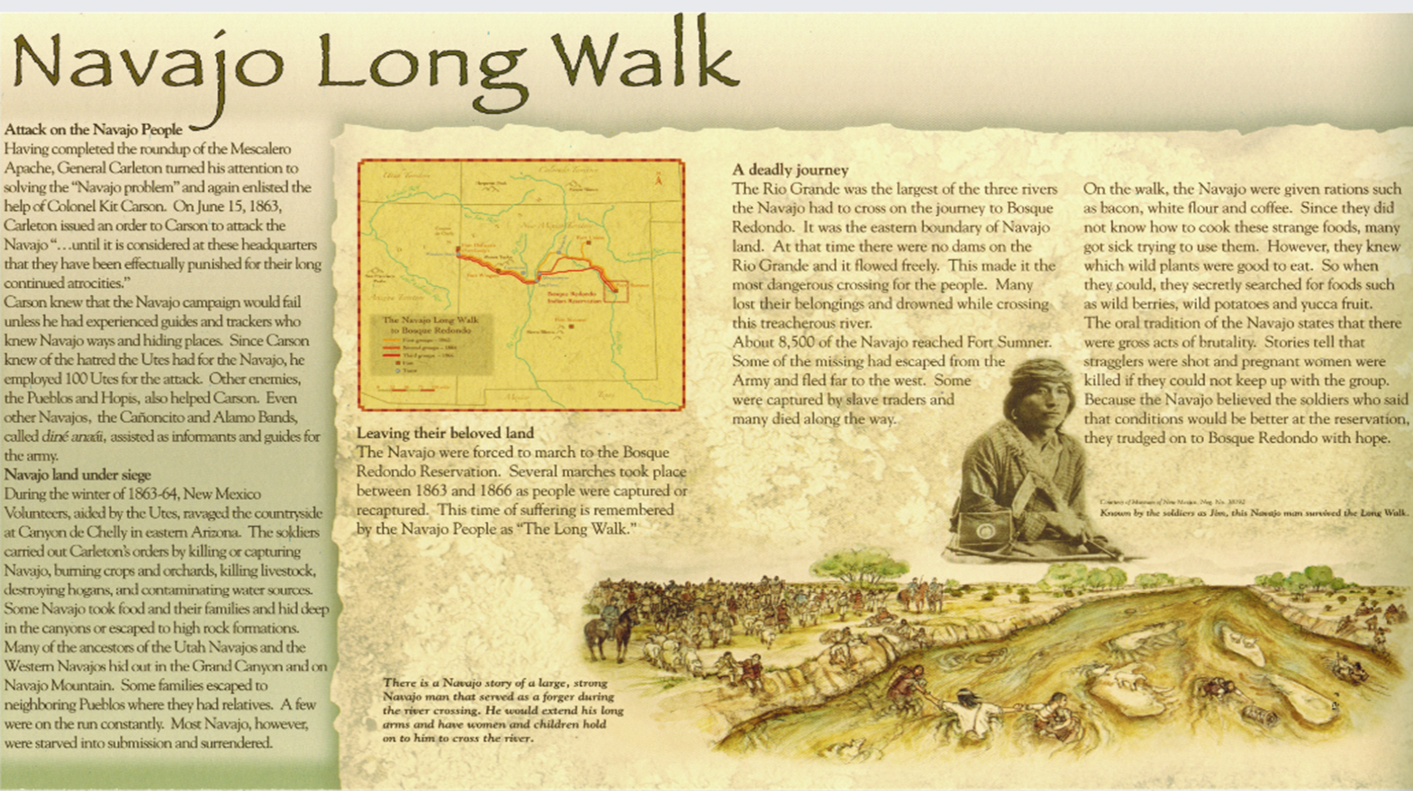
Long Walk Graphic Organizer

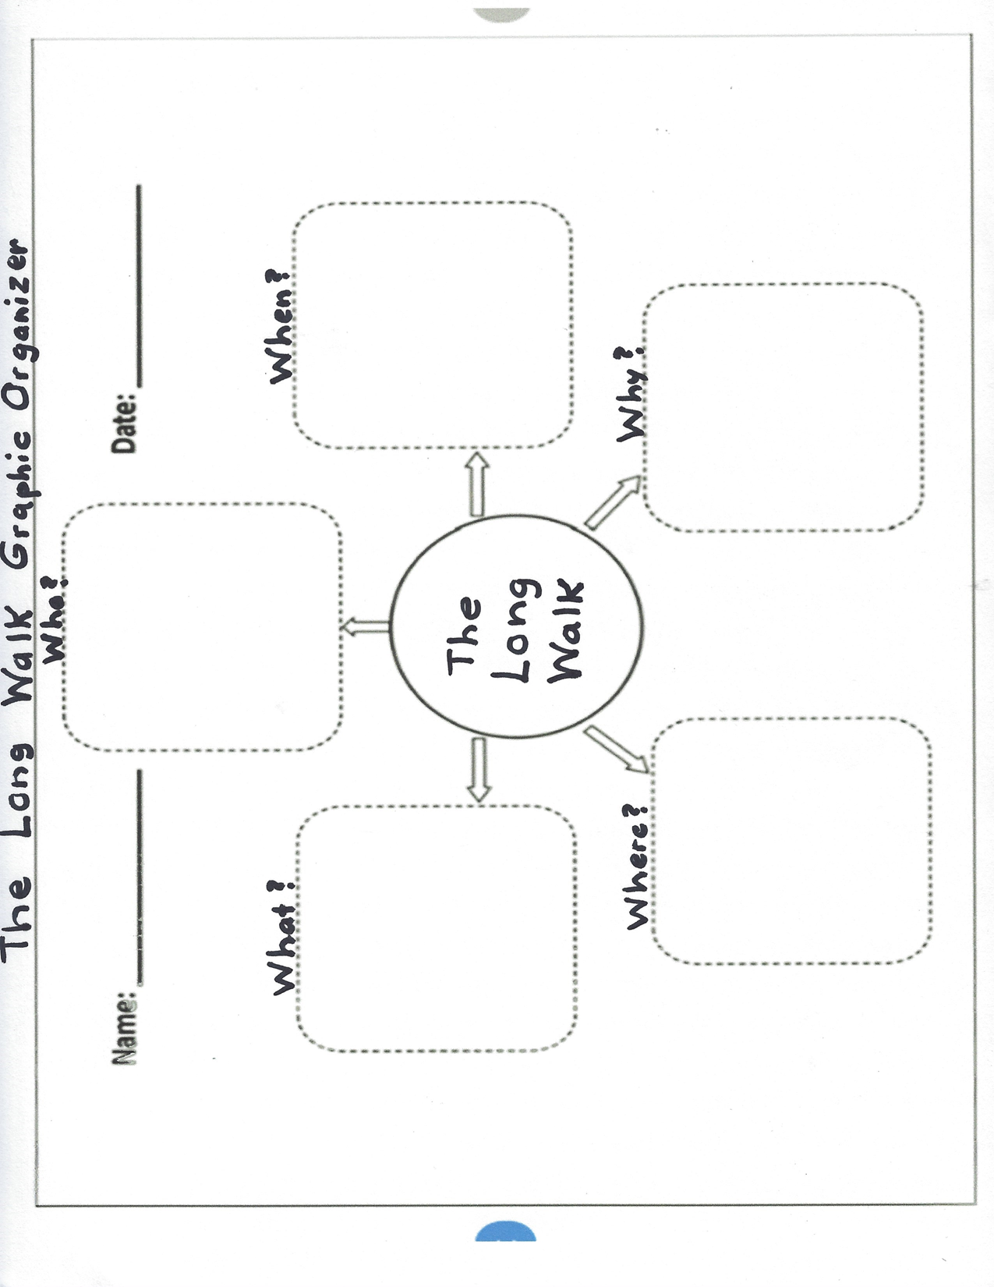

‘’
The Long Walk Graphic Organizer Answer Key

Name: ________________ Who? Date: _______________
Navajo (Dine’) people
U.S. Military: General Carleton & Colonel Kit Carson
Navajo’s enemies: Utes, Pueblos, Hopis

When?
The Long Walk took place between 1863 and 1866.
What?
U.S. military employed the Navajo’s enemies to attack the Navajo People, killing and capturing them and destroying their homes and lands. The Navajo (Dine’) were forced to leave their land and march to Bosque Redondo. On this Long Walk, many Navajo died from drowning, or starvation, or being killed by the soldiers.

The Long Walk

Where? Why?
The U.S. military saw the Navajo people as the “Navajo Problem”. They attacked them in order to force them to leave their homeland to be relocated on a reservation at Bosque Redondo, New Mexico.

The Navajo (Dine’) people were forced to leave their homeland in eastern Arizona and take the Long Walk to Bosque Redondo Reservation in New Mexico.

Jamboard Sticky Note Resource Sheet
Indian
Removal
Act 1830

Homestead
Act 1862

During the Long Walk the Navajo (Dine’) men, women, and children had to march between 250 and 450 miles to Bosque Redondo.

1868 Navajo chief Barboncito, along with numerous other leaders, sign a treaty with General William T. Sherman, agreeing to peace with the Americans in exchange for loss of rights.
1864-1866 “Long Walk” Navajo and Mescalero Apache forcibly relocated to Bosque Redondo Reservation.
The Navajo (Dine’) were forced to take on white American cultural values (cultural assimilation)

The Navajo (Dine’) faced lack of food and water leading to starvation, disease, and death.
When the Navajo (Dine’) become exhausted during the Long Walk, the soldiers would shoot them instead of allowing them to rest,
During the Long Walk, the soldiers showed no regard for women, children, or families.

The Navajo walked southeastward through rough terrain across the Colorado Plateau, through timbered mountain slopes and rough canyons and across rivers of frozen lava.

Answer Key - Jamboard Sticky Notes Put into Sequential Order and Categorized

Sticky Note Facts in Sequential Order of the Long Walk:
1868 Navajo chief Barboncito, along with numerous other leaders, sign a treaty with General William T. Sherman, agreeing to peace with the Americans in exchange for loss of rights.
1862 Homestead Act

1864-1866 “Long Walk” Navajo and Mescalero Apache forcibly relocated to Bosque Redondo Reservation.

1830 Indian Removal Act

Sticky Note Facts with Social Aspects of the Long Walk:

During the Long Walk, the soldiers showed no regard for women, children, or families.
The Navajo (Dine’) were forced to take on white American cultural values (cultural assimilation)

Sticky Note Facts with Physical Aspects of the Long Walk:

The Navajo walked southeastward through rough terrain across the Colorado Plateau, through timbered mountain slopes and rough canyons and across rivers of frozen lava.
The Navajo (Dine’) faced lack of food and water leading to starvation, disease, and death.
Navajo (Dine’) men, women, and children had to march between 250 and 450 miles to Bosque Redondo.
When the Navajo (Dine’) become exhausted during the Long Walk, the soldiers would shoot them instead of allowing them to rest,

The Long Walk Maps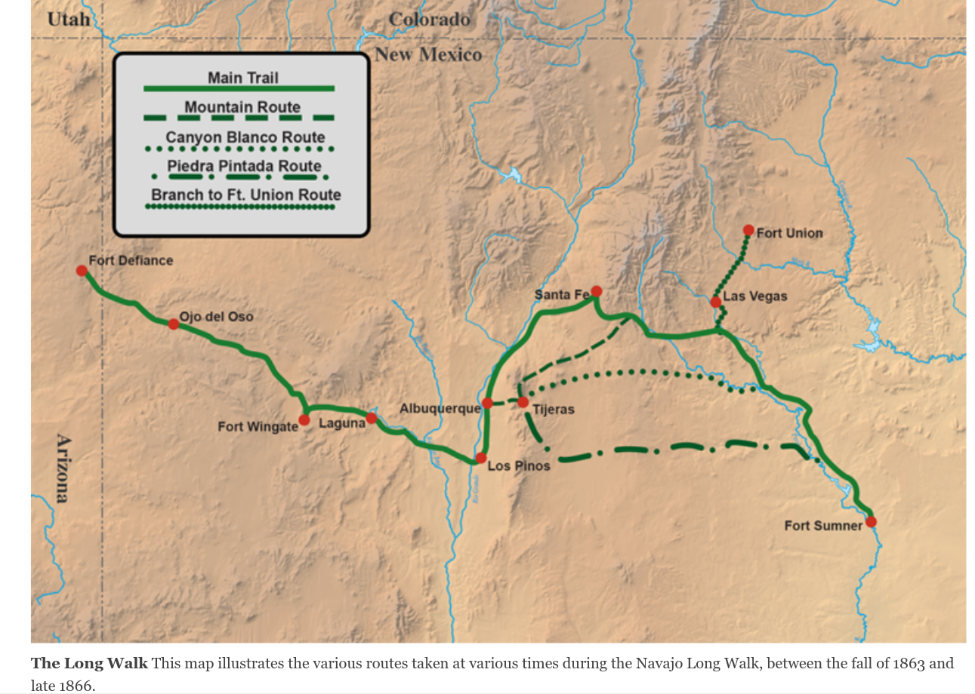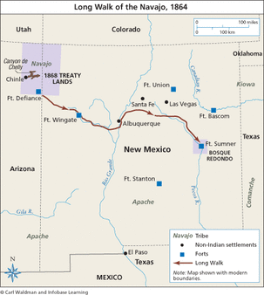
3-D Map of the “Long Walk” Rubric

 | 4 points  Excellent | 3 points  Strong | 2 points  Satisfactory | 1 point  Emergent | 0 Points  Incomplete
Landmarks | Labeled at least 6 landmarks | Labeled at least 4 landmarks | Labeled at least 2 landmarks | Labeled 1 landmark | Labeled 0 landmarks
Physical Features | Labeled landforms | Labeled landforms | Labeled landforms | Labeled landforms | Did not include labeled landforms
Compass Rose | Correctly labeled all 8 cardinal and intermediate directions | Correctly labeled 5-7 cardinal and intermediate directions | Correctly labeled 3-4 cardinal and intermediate directions | Correctly labeled 1-2 cardinal and intermediate directions | Did not include cardinal and intermediate directions
Map Title | Included map title | - | - | - | Did not include map title
Key | Includes 5 elements | Includes 4 elements | Includes 3 elements | Includes 1-2 elements | Did not include elements
Routes | Includes all 5 routes | Includes 4 routes | Includes 3 routes | Includes 1-2 routes | Did not include a route
Towns | Labeled 7 towns | Labeled 5-6 towns | Labeled 3-4 towns | Labeled 1-2 towns | Did not label any towns
Forts | Labeled 4 Forts | Labeled 3 Forts | Labeled 2 Forts | Labeled 1 Fort | Did not label any Forts
Due Date | Project was turned in on time | Project was turned in 1 day late | Project was turned in 2 days late | Project was turned in 3 days late | Project was turned in 4 days or later

3-D Maps of the Long Walk - SAMPLES
