Name____________________________________________
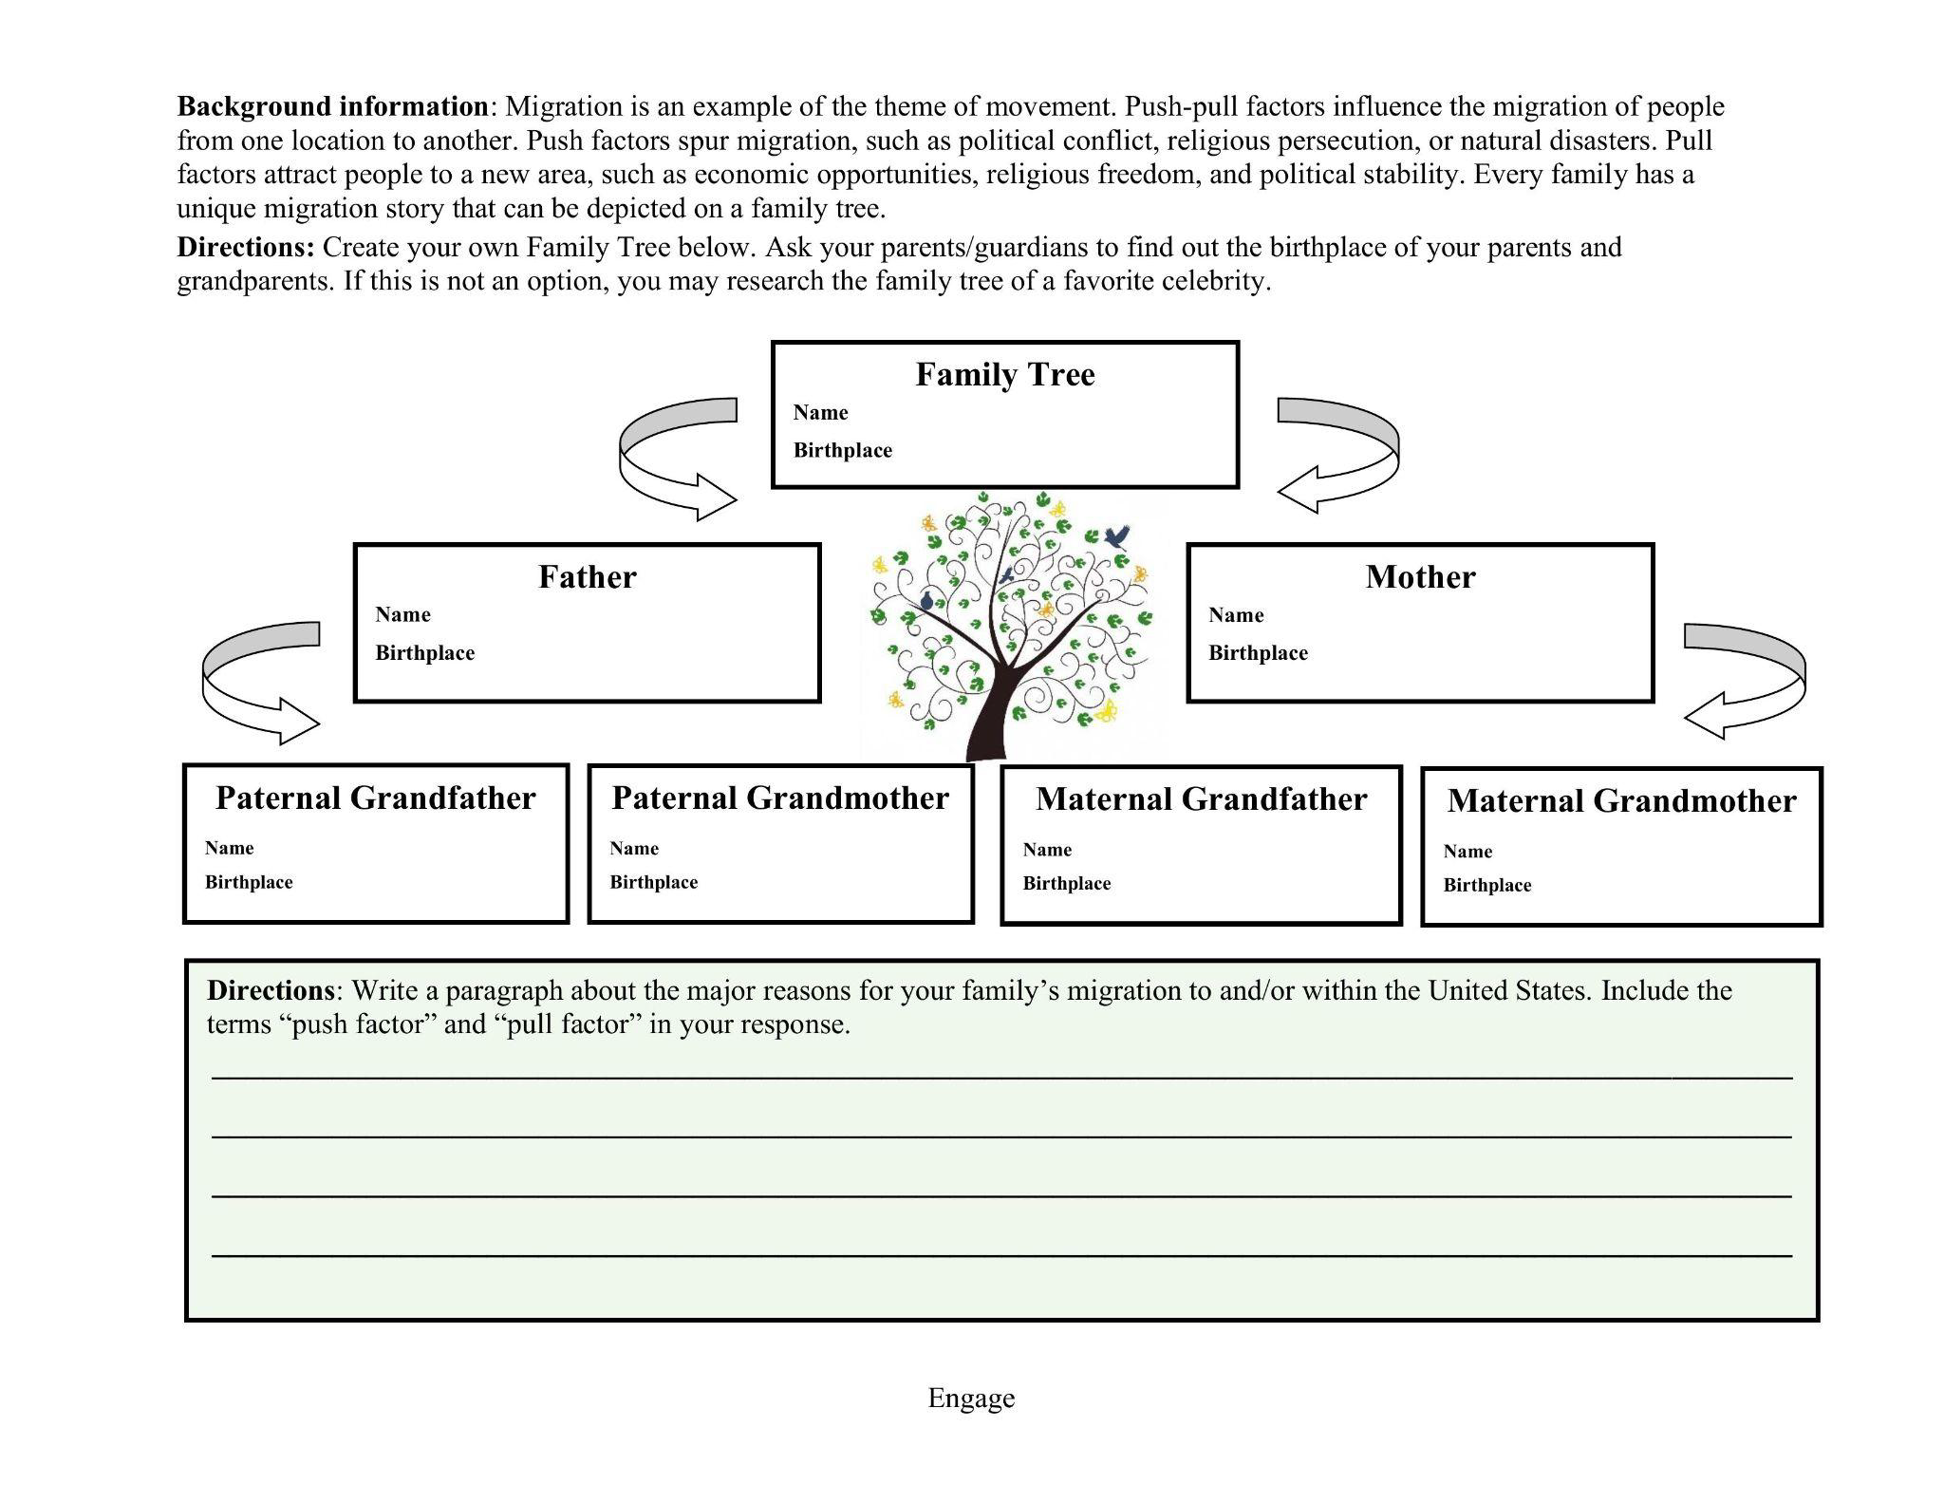

Name________________________________

Navajo Diné Long Walk (Hwééldi) (1863-1866) - Map Worksheet

Directions: Use the maps of the Long Walk (Hwééldi) to answer the following questions. One map is zoomed-out (Version 1) and the other map is zoomed-in (Version 2). It is recommended that students color on the zoomed-in map version (Version 2).

- Describe the location of the traditional Navajo (Diné) homeland.

- Describe the relative location of the sacred mountains to the traditional Navajo (Diné) homeland.

- Using color pencils, shade the boxes surrounding the four sacred mountains (Mt. Hesperus, Blanca Peak, Mt. Taylor and San Francisco Peaks) on the map and key. In total, how many sacred mountains do the Navajo (Diné) revere?

- Identify the fort that served as the starting point of the Long Walk (Hwééldi).

- Identify the fort that served as the ending point of the Long Walk (Hwééldi).

- How many different routes did the Long Walk (Hwééldi) include? Using color pencils, shade the key and map.

- What is a likely reason why the route of the Long Walk (Hwééldi) didn’t proceed more directly from Fort Wingate to Fort Sumner?

- Using the map scale, estimate the distances traveled on the Long Walk (Hwééldi).
- 1863 Route:
- 1864 Route:
- 1866 Route:

- Explain two physical features that made the Long Walk (Hwééldi) challenging.

- What was the name of the reservation at the final destination of the Long Walk (Hwééldi)?

- Identify the river that flows through the Bosque Redondo Indian Reservation.

- What is the connection between the federal government and the forts shown on the map?

Navajo Diné Long Walk (Hwééldi) (1863-1866) Map Worksheet - Answer Key

- Describe the location of the traditional Navajo (Diné) homeland.
Answers will vary. Possible answers include:
- The traditional Navajo (Diné) homeland is located in Utah, Arizona, New Mexico, and Colorado.
- The traditional Navajo (Diné) homeland is located primarily in Arizona and New Mexico and extends into the southern parts of Utah and Colorado.
- The traditional Navajo (Diné) homeland is located in the U.S. Southwest.

- Describe the relative location of the sacred mountains to the traditional Navajo (Diné) homeland.
Answers will vary. Possible answers include:
- Most of the sacred mountains are located in or relatively close to the traditional Navajo (Diné) homeland, while one sacred mountain is located farther away.
- Two of the sacred mountains are located within the traditional Navajo (Diné) homeland, while the others are located along the edge of the traditional Navajo (Diné) homeland.
- Most of the sacred mountains are near the edge of the traditional Navajo (Diné) homeland.

- Using color pencils, shade the boxes surrounding the four sacred mountains (Mt. Hesperus, Blanca Peak, Mt. Taylor and San Francisco Peaks) on the map and key. In total, how many sacred mountains do the Navajo (Diné) revere?
The Navajo (Diné) revere six sacred mountains: Mt. Hesperus (Dibé Nitsaa), Blanca Peak (Sisnaajini), Mt. Taylor (Tsoodził), San Francisco Peaks (Dookʼoʼoosłííd), Gobernador Knob (Ch'óol'í'í), and Huerfano Mountain (Dził Náʼoodiłii).

- Identify the fort that served as the starting point of the Long Walk (Hwééldi).
The fort that served as the starting point of the Long Walk (Hwééldi) is Fort Defiance.

- Identify the fort that served as the ending point of the Long Walk (Hwééldi).
The fort that served as the ending point of the Long Walk (Hwééldi) is Fort Sumner.

- How many different routes did the Long Walk (Hwééldi) include? Using color pencils, shade the key and map.
The Long Walk (Hwééldi) included three different routes. One route in 1863, a second route in 1864, and a third route in 1866.

- What is a likely reason why the route of the Long Walk (Hwééldi) didn’t proceed more directly from Fort Wingate to Fort Sumner?
Answers will vary. Possible answers include:
- Federal troops participating in the forced removal of the Navajo (Diné) from their traditional homelands needed to obtain food and/or additional supplies from one or more of the following places: Albuquerque, Santa Fe, and Fort Union.
- Federal troops participating in the forced removal of the Navajo (Diné) from their traditional homelands wanted to follow the Rio Grande River, as the river provided freshwater.
- Federal troops participating in the forced removal of the Navajo (Diné) from their traditional homelands wanted to follow trails with which they were more familiar.

- Using the map scale, estimate the distances traveled on the Long Walk (Hwééldi).
- 1863 Route: 385 miles
- 1864 Route: 325 miles
- 1866 Route: 320 miles
- Explain two physical features that made the Long Walk (Hwééldi) challenging.
Physical features that made the Long Walk (Hwééldi) challenging include mountainous terrain, arid climate, and limited freshwater sources.
Answers will vary. Possible answers include:
- The mountainous terrain made the Long Walk (Hwééldi) difficult because of the lack of proper clothing and shoes and the range of physical abilities of the Navajo (Diné). Some of the Navajo (Diné) forced on the Long Walk (Hwééldi) were elderly and pregnant, who found mountainous terrain physically challenging.
- The arid climate made the Long Walk (Hwééldi) difficult because the Navajo (Diné) were exposed to the harsh sun and dry climate while marching hundreds of miles. Dehydration and sun exposure threatened the lives of the Navajo (Diné).
- Limited freshwater sources made the Long Walk (Hwééldi) difficult because freshwater is necessary for life.

- What was the name of the reservation at the final destination of the Long Walk (Hwééldi)?
The name of the reservation at the final destination of the Long Walk (Hwééldi) is called Bosque Redondo Indian Reservation.

- Identify the river that flows through the Bosque Redondo Indian Reservation.
The river that flows through the Bosque Redondo Indian Reservation is the Pecos River.

- What is the connection between the federal government and the forts shown on the map?
Answers will vary. Possible answers include:
- The forts were staffed with federal troops.
- The forts represented the presence of the federal government.
- The forts were federal property.
- The forts allowed the federal government to extend its reach into Arizona and New Mexico.
- The forts enabled the federal government to exert its power in the U.S. Southwest.

Name__________________________
Describing an Historical Event - Graphic Organizer
Why
Why did the federal government forcibly relocate the Navajo from their homeland?

The Navajo Long Walk
Hwéeldi

Who
Name the indigenous people forced on the Long Walk.

When
In what years did the Long Walk to Bosque Redondo occur?

When was the internment of indigenous people at Bosque Redondo?

In what year did the internment of indigenous people at Bosque Redondo end?

What
What were conditions like for the Navajo during the Long Walk?

What were conditions like for the Navajo in the Bosque Redondo internment camp?

To what extent do these conditions fit the definition of genocide?

Where
Describe where the Navajo were living before the Long Walk?

Describe the location of Bosque Redondo.

Describe the route the Navajo people traveled to reach Bosque Redondo.

Connection to sacred places
From the Navajo point of view, what is the connection between the historical event of the Long Walk and their sacred lands?

Answer Key: Describing an Historical Event - Graphic Organizer

Who
Q: Name the indigenous people forced on the Long Walk.
A: Navajo (Diné) and Mescalero Apache

When
Q: In what years did the Long Walk to Bosque Redondo occur?
A: 1863-1866

Q: When was the internment of indigenous people at Bosque Redondo?
A: 1864-1868

Q: In what year did the internment of indigenous people at Bosque Redondo end?
A: 1868

Where
Q: Describe where the Navajo were living before the Long Walk.
A: The Navajo lived in an area that they called Dinétah. This area is marked by four sacred mountains and stretches across the modern-day states of Colorado, New Mexico, Utah and Arizona. Rivers like the San Juan River and Little Colorado River flow through Dinétah.

Q: Describe the location of Bosque Redondo.
A: Located east of Dinétah, Bosque Redondo is located in the modern-day state of New Mexico. Bosque Redondo is located on a sparsely populated piece of land unsuitable for farming. The Pecos River flows through Bosque Redondo.

Q: Describe the route the Navajo people traveled to reach Bosque Redondo.
A: There were three different routes. All three routes started in the traditional Navajo homeland at Fort Defiance and continued past Fort Wingate to Albuquerque. The 1863 route proceeded to Santa Fe and Fort Union before reaching the final destination of Fort Sumner, the army fort located in the Bosque Redondo reservation. The 1864 and 1866 routes bypassed Santa Fe and Fort Union to reach Bosque Redondo.

Why
Q: Why did the federal government forcibly relocate the Navajo from their homeland?
A: Following the Mexican-American War and the signing of the Treaty of Guadalupe Hidalgo in 1848, the United States U.S. federal government wanted to expand its territory west of the Mississippi River and increase settlement in the Southwest. The Navajo (Diné) Nation was waging armed resistance against further incursion by white settlers and other tribes onto Navajo homelands.

What
Q: What were conditions like for the Navajo during the Long Walk?
A: Conditions were appalling. U.S. federal troops forced poorly clothed Navajo to walk hundreds of miles without protection from the physical elements. Hundreds of Navajo died during the Long Walk from exhaustion, malnourishment, and exposure to the elements.

Q: What were conditions like for the Navajo in the Bosque Redondo internment camp?
A: Conditions were appalling. The Navajo were expected to abandon their cultural values and embrace American cultural values like farming, Christianity, and English. Since the land was unsuitable for farming, the Navajo faced deprivation, starvation, diseases like dysentery and smallpox, and death. The Navajo did not know how to prepare food with the provided rations. The 400-square-mile reservation had little firewood. The Pecos River, which flows through the reservation, was laden with salt that weakened the soil and caused intestinal problems. One out of four Navajo died at Bosque Redondo.

Q: To what extent do these conditions fit the definition of genocide?
A: Answers will vary, however, it is recommended students answer this question within the parameters of the UN definition of genocide. The United Nations definition of genocide is: Any of the following acts committed with the intent to destroy, in whole or in part, a national, ethnic, racial, or religious group. These acts fall into five categories:
- Killing members of the group.
- Causing serious bodily or mental harm to members of the group.
- Deliberately inflicting on the group conditions of life calculated to bring about its physical destruction in whole or in part.
- Imposing measures intended to prevent births within the group.
- Forcibly transferring children of the group to another group. https://www.un.org/en/genocideprevention/genocide.shtml

Connection to sacred places
Q: From the Navajo point of view, what is the connection between the historical event of the Long Walk and their sacred lands?
A: The Long Walk forcibly removed the Navajo from their sacred lands. They did not have access to their sacred lands during the Long Walk and internment at Bosque Redondo. The Navajos' resolve to return to their sacred lands played a major role in their negotiations with the US government for the Navajo Treaty of 1868.

Name____________________ Navajo Treaty of 1868 - Graphic Organizer

Directions: For each treaty term, write a summary of what it means to the Navajo people. Then evaluate how the treaty term impacted tribal sovereignty. Explain why it would be considered a gain or concession to Navajo tribal sovereignty.

Treaty Terms  Paraphrased version | Summary  Describe what it means | Impact on Tribal Sovereignty  Explain if it is a gain or concession
Article 1: Offenders Among the Whites

If bad men among the whites, or among other people subject to the authority of the United States, commits a crime against the person or property of the Indians, the offender will be arrested and punished according to the laws of the United States. The injured person will be reimbursed for their losses.

Article 1: Offenders Among the Indians

If bad men among the Indians commits a crime against the person or property of anyone (white, black, or Indian) subject to the authority of the United States, the Navajo tribe agrees to give up the offender to be tried and punished according to the laws of the United States. In case the tribe refuses to do so, the injured person shall be reimbursed for his loss from the annuities (payments) or other money due to them under this treaty.

Treaty Terms  Paraphrased version | Summary  Describe what it means | Impact on Tribal Sovereignty  Explain if it is a gain or concession
Article 2: Reservation Boundaries

The United States agrees that the land between the 37th degree of north latitude and old Fort Defiance and west by the longitude of 109° 30' west of Greenwich, including Canyon de Chelly, will be set apart for the Navajo reservation. The United States agrees that no one except the people of the Navajo Nation and some officers, soldiers, agents, and employees of the United States government will be allowed to enter the Navajo lands.

Article 5: Land Selection for Farming

If any individual belonging to the Navajo tribe, being the head of a family, wants to start farming, he shall have the privilege to select a tract of land within the reservation, not exceeding 160 acres. The tract shall be certified and recorded in the “land-book” and shall cease to be held in common. It shall be the exclusive possession of the person selecting it, and of his family, so long as he or they may continue to cultivate (farm) it.

Treaty Terms  Paraphrased version | Summary  Describe what it means | Impact on Tribal Sovereignty  Explain if it is a gain or concession
Article 6: Education of Navajo Children

In order to ensure the civilization of the Indians entering this treaty, the education of Navajo children is necessary. Parents must make their children, both boys and girls, between the ages of six and sixteen to attend the U.S. government run schools. It is the duty of the U.S. government’s Indian agent to make sure that all parents comply. For every 30 children that attend the school, the U.S. will provide a classroom and a teacher who can provide an English education.

Article 8: Annual Goods & Appropriations

The United States agrees to deliver on the first day of September of each year for ten years the following articles: articles of clothing, food, or raw materials, not exceeding in value five dollars per Indian. In addition, the sum of ten dollars for each person who engages in farming or mechanical pursuits.

Treaty Terms  Paraphrased version | Summary  Describe what it means | Impact on Tribal Sovereignty  Explain if it is a gain or concession
Article 9: Rights to Outside Territories

The tribes who are parties to this treaty hereby agree that they will relinquish (give up) all right to occupy any territory outside their reservation . . . but retain the right to hunt on any unoccupied lands contiguous (connected) to their reservation.

Article 9: Other Agreements

The said Indians further expressly agree:
1st They will make no opposition to the construction of railroads now being built or hereafter to be built . . .
2nd They will not interfere with the peaceful construction of any railroad not passing over their reservation.
3rd They will not attack any persons at home or traveling, nor disturb any wagon trains, coaches, mules or cattle belonging to the people of the U.S.
4th They will never capture or carry off from the settlements women or children.
5th They will never kill or scalp white men, nor attempt to do them harm.
6th They will allow the construction of railroads, wagon roads, mail stations, or other utilities that the U.S. government might need to build. If the U.S. needs to construct buildings or roads on the Navajo reservation, they will pay the tribe whatever the damage costs.
7th They will allow the U.S. to build military posts and roads to and from those posts.

Treaty Terms  Paraphrased version | Summary  Describe what it means | Impact on Tribal Sovereignty  Explain if it is a gain or concession
Article 11: Timeline for Navajo Return Home

The Navajos also hereby agree that at any time after the signing of this treaty that they will proceed in such manner . . . to the reservation herein provided for, the United States paying for their subsistence en route, and providing a reasonable amount of transportation for the sick and feeble.

Article 12: Appropriations, Livestock, & Corn

The U.S. government will distribute the sum of 150 thousand dollars to the Navajo people as follows:
1st The actual cost of the removal of the tribe from Bosque Redondo to the Navajo reservation.
2nd The purchase of fifteen thousand sheep and goats.
3rd The purchase of five hundred beef cattle and a million pounds of corn, to be collected and held at the military post nearest the reservation, subject to the orders of the agent, for the relief of the needy during the coming winter.

Treaty Terms  Paraphrased version | Summary  Describe what it means | Impact on Tribal Sovereignty  Explain if it is a gain or concession
Article 13: Reservation as a Permanent Home

The tribe herein named . . . agree to make the reservation herein described their permanent home and they will not as a tribe make any permanent settlement elsewhere, reserving the right to hunt on the lands adjoining the said reservation called theirs.

Article 13: Penalty For Leaving Reservation

It is further agreed and understood . . . that if any Navajo shall leave the reservation herein described to settle elsewhere, he shall forfeit all the rights, privileges, and annuities (payments) conferred by the terms of this treaty.

Answer Key: Navajo Treaty of 1868 – Graphic Organizer
Directions: For each treaty term, write a summary of what it means to the Navajo people. Next evaluate how the treaty term impacted tribal sovereignty. Explain why it would be considered a gain or concession to Navajo tribal sovereignty.

Treaty Terms  Paraphrased version | Summary  Describe what it means | Impact on Tribal Sovereignty  Explain if it is a gain or concession
Article 1: Offenders Among the Whites  If bad men among the whites, or among other people subject to the authority of the United States, commits a crime against the person or property of the Indians, the offender will be arrested and punished according to the laws of the United States. The injured person will be reimbursed for their losses. | This section provides justice to Navajos who have had a crime committed against them or their property by an offender who is white or non-native. “According to the laws of the US” gives the power to the US governmental authorities to handle the arrest, trial, and punishment of the non-native offender. | Gain: Navajos are offered legal protection from white or non-native offenders by the US government.  Concession: Although there is a process in place for arresting and punishing a non-native offender, the authority to do so is given to the US government. The tribal system of justice would not be allowed.
Article 1: Offenders Among the Indians  If bad men among the Indians commits a crime against the person or property of anyone (white, black, or Indian) subject to the authority of the United States, the Navajo tribe agrees to give up the offender to be tried and punished according to the laws of the United States. In case the tribe refuses to do so, the injured person shall be reimbursed for his loss from the annuities (payments) or other money due to them under this treaty. | This section provides justice to anyone who has had a crime committed against them or their property by an offender who is Navajo. The tribe is required to turn over the offender to the US governmental authorities. If the tribe does not turn over the offender and the injured party is Navajo, then any money settlement will come out of the payments owed to them by the treaty. | Concession: If the offender is Navajo, the tribe is obligated to turn them over to the US govt authorities taking this power away from the tribal government.  Gain: The language hedges and grants the tribe an option to not turn in the offender, which somewhat acknowledges tribal sovereignty, however, if the tribe opts to do so, the payment for losses to the injured party will be pulled out of the treaty money owed them, which is a Concession.

Treaty Terms  Paraphrased version | Summary  Describe what it means | Impact on Tribal Sovereignty  Explain if it is a gain or concession
Article 2: Reservation Boundaries  The United States agrees that the land between the 37th degree of north latitude and old Fort Defiance and west by the longitude of 109° 30' west of Greenwich, including Canyon de Chelly, will be set apart for the Navajo reservation. The United States agrees that no one except the people of the Navajo Nation and some officers, soldiers, agents, and employees of the United States government will be allowed to enter the Navajo lands. | This section delineates the exact borders of the Navajo reservation and protects their lands from outsiders. The US government specifies certain exceptions, mainly the military and govt agents who would only do so for official govt purposes. | Gain: By setting exact latitude/longitude coordinates, the US govt is officially recognizing the tribal boundaries. This area aligns with part, but not all, of the Navajo traditional homelands. By keeping outsiders to a minimum, the US govt is showing respect of the Navajo’s tribal sovereignty
Article 5: Land Selection for Farming  If any individual belonging to the Navajo tribe, being the head of a family, wants to start farming, he shall have the privilege to select a tract of land within the reservation, not exceeding 160 acres. The tract shall be certified and recorded in the “land-book” and shall cease to be held in common. It shall be the exclusive possession of the person selecting it, and of his family, so long as he or they may continue to cultivate (farm) it. | This section sets up an allotment system of individual land ownership that promotes an agricultural way of life vs the traditional communal/tribal guardianship of land. It rewards Navajo families with prime land choices if they commit to farming and penalizes families with loss of land if they discontinue farming their land. | Concession: By offering privileged land selection rights and property ownership to families who will commit to farming, the US government is removing prime arable lands from tribal jurisdiction. This could be viewed as a violation of tribal sovereignty. As Navajos were traditionally pastoralists (sheep & goats) this land selection policy pushed the dominant settler values onto the tribal members.

Treaty Terms  Paraphrased version | Summary  Describe what it means | Impact on Tribal Sovereignty  Explain if it is a gain or concession
Article 6: Education of Navajo Children  In order to ensure the civilization of the Indians entering this treaty, the education of Navajo children is necessary. Parents must make their children, both boys and girls, between the ages of six and sixteen to attend the U.S. government run schools. It is the duty of the U.S. government’s Indian agent to make sure that all parents comply. For every 30 children that attend the school, the U.S. will provide a classroom and a teacher who can provide an English education. | This section mandates that all Navajo children (6-16 yrs.) must attend a US government run school that will offer them an English education. The policy promises to provide classrooms and teachers at the government’s expense. | Concession: This policy forces Navajo families to send their children away to US government run schools for an English education. These schools were boarding schools meant to assimilate Navajo children into the dominant settler cultural values. Navajo traditional ways were not taught. The treaty terms dictating how Navajo children were to be educated, completely disavowed Navajo tribal sovereignty.
Article 8: Annual Goods & Appropriations  The United States agrees to deliver on the first day of September of each year for ten years the following articles: articles of clothing, food, or raw materials, not exceeding in value five dollars per Indian. In addition, the sum of ten dollars for each person who engages in farming or mechanical pursuits. | This section promises delivery of goods, clothing, and food to the Navajo people for ten years. An incentive of $10 per person will be awarded to each Navajo who becomes a farmer of works in mechanical jobs. | Gain: The annual guarantee of clothing, food, and goods for ten years gave the Navajo a degree of insurance against “hard times” and a basic allowance during their first decade to reestablish their homelands.

Treaty Terms  Paraphrased version | Summary  Describe what it means | Impact on Tribal Sovereignty  Explain if it is a gain or concession
Article 9: Rights to Outside Territories  The tribes who are parties to this treaty hereby agree that they will relinquish (give up) all right to occupy any territory outside their reservation . . . but retain the right to hunt on any unoccupied lands contiguous (connected) to their reservation. | This section mandates that the Navajo give up rights to lands located outside the US government established boundaries, but guaranteed hunting rights on unsettled lands directly adjacent to the Navajo reservation. | Gain: The Navajo could still hunt on lands directly adjacent to their reservation which was an advantage since the range of animal habitats exist beyond the reservation boundaries.  Concession: The Navajo did not get the full extent of their traditional homelands.
Article 9: Other Agreements  The said Indians further expressly agree:  1st They will make no opposition to the construction of railroads now being built or hereafter to be built.  2nd They will not interfere with the peaceful construction of any railroad not passing over their reservation.  3rd They will not attack any persons at home or traveling, nor disturb any wagon trains, coaches, mules or cattle belonging to the people of the U.S.  4th They will never capture or carry off from the settlements women or children.  5th They will never kill or scalp white men, nor attempt to do them harm.  6th They will allow the construction of railroads, wagon roads, mail stations, or other utilities that the U.S. government might need to build. If the U.S. needs to construct buildings or roads on the Navajo reservation, they will pay the tribe whatever the damage costs.  7th They will allow the U.S. to build military posts and roads to and from those posts. | This section requires the Navajo to allow the building of railroads, military posts, and roads adjacent to and across their reservation. The Navajo promise to keep peaceful relations with settlers and non-natives passing through the reservation. | Concession: The Navajo have no choice in the decision-making process with regards to the building of railroads through their reservation lands. This could be viewed as a violation of tribal sovereignty.  Gain: The US government guarantees payment to the Navajo tribe for any damages caused by the construction of necessary buildings or roads on reservation lands. This is similar to eminent domain.  Gain: The agreement to peaceful relations between the Navajo and the settlers would help to prevent future wars.

Treaty Terms  Paraphrased version | Summary  Describe what it means | Impact on Tribal Sovereignty  Explain if it is a gain or concession
Article 11: Timeline for Navajo Return Home  The Navajos also hereby agree that at any time after the signing of this treaty that they will proceed in such manner . . . to the reservation herein provided for, the United States paying for their subsistence en route, and providing a reasonable amount of transportation for the sick and feeble. | This section prescribes that the Navajo journey home can begin immediately after the treaty is signed. It also stipulates that the US government will pay expenses associated with the move and provide transportation for the elderly and sick. | Gain: The Navajo were granted their wish for an immediate return to their traditional homelands. In addition, the US government paid the travel expenses and provided transportation for tribal members who were too weak or sick to walk the route home.
Article 12: Appropriations, Livestock, & Corn  The U.S. government will distribute the sum of 150 thousand dollars to the Navajo people as follows:  1st The actual cost of the removal of the tribe from Bosque Redondo to the Navajo reservation.  2nd The purchase of fifteen thousand sheep and goats.  3rd The purchase of five hundred beef cattle and a million pounds of corn, to be collected and held at the military post nearest the reservation, subject to the orders of the agent, for the relief of the needy during the coming winter. | This section stipulates that the US government provide $150,000 to fund the cost of the return trip to the Navajo reservation and both livestock and corn to help the Navajo survive the upcoming winter. | Gain: The Navajo received US government assistance with the cost of the return journey to their reservation. They also received livestock to help them start their herds and corn to feed them through their first winter.

Treaty Terms  Paraphrased version | Summary  Describe what it means | Impact on Tribal Sovereignty  Explain if it is a gain or concession
Article 13: Reservation as a Permanent Home  The tribe herein named . . . agree to make the reservation herein described their permanent home and they will not as a tribe make any permanent settlement elsewhere, reserving the right to hunt on the lands adjoining the said reservation called theirs. | This section sets clear boundaries for the Navajo reservation and prohibits the tribe from settling anywhere else. | Gain: The Navajo received assurance from the US government that the reservation lands would be their permanent home.  Concession: There is no provision for the Navajo to gain back the full extent of their traditional homelands, a restriction on tribal sovereignty.
Article 13: Penalty For Leaving Reservation  It is further agreed and understood . . . that if any Navajo shall leave the reservation herein described to settle elsewhere, he shall forfeit all the rights, privileges, and annuities (payments) conferred by the terms of this treaty. | This section makes it clear that the US government preference is for Navajos to stay on their reservation. If a Navajo should decide to leave, the penalty will be a loss of any rights and financial benefits provided by the treaty. | Concession: The Navajo have restrictions placed on an individual’s choice in the matter of leaving the reservation. This could be viewed as a violation of tribal sovereignty as such matters should be decided by the tribe, not the federal government.

Name___________________________________

Smithsonian Magazine Article
National Museum of the American Indian
“The Treaty that Reversed a Removal - the Navajo Treaty of 1868 - Goes on View”
https://www.smithsonianmag.com/blogs/national-museum-american-indian/2018/02/22/treaty-that-reversed-a-removal-navajo-treaty-1868-goes-on-view/

3-2-1 Reflection Questions Worksheet
Answers to be written on the 3-2-1 Card below.
3 According to the article, what important historical events occurred on the listed dates?
2 During the treaty negotiations, what did each of these men propose?
1 Why is the Navajo Treaty of 1868 so unique and extraordinary?
3-2-1 Reflection
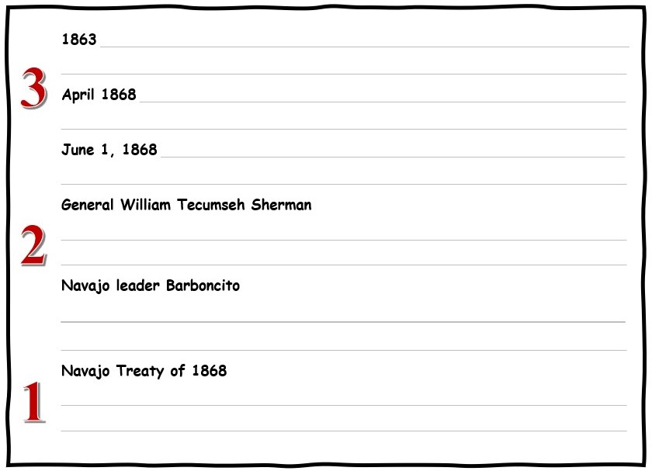

Answer Key: 3-2-1 Reflection Questions

3 According to the article, what important historical events occurred on the listed dates?
1863 The US Army removed the Navajo people from their homelands and began
the forced march to Bosque Redondo.
April 1868 A delegation of Navajo leaders went to Washington D.C. to appeal to
President Johnson for the return of their people to their homelands.
June 1, 1868 Navajo leaders signed the treaty that reversed their removal and
returned a portion of their original homelands to them.

2 During the treaty negotiations, what did each of these men propose?
General William Tecumseh Sherman proposed that the Navajo move to Indian
Territory (Oklahoma).
Navajo leader Barboncito proposed that the Navajo people be allowed to return
to their traditional homelands.

1 Why is the Navajo Treaty of 1868 so unique and extraordinary?
Navajo Treaty of 1868 is extraordinary because it is the ONLY treaty in which
a Native American tribe was able to negotiate a reversal and return to their
traditional homelands.

Historic Diamante Poem – Directions and Example

Directions: Based upon the information you learned about the Navajo Treaty of 1868
create an “Historic Diamante” Poem.

A diamante is composed of seven lines of unrhymed poetry. Each line of a diamante follows a
specific format. The beginning and ending lines are the shortest while the middle lines are
progressively longer, giving the written poem the appearance of a diamond shape. In fact, the
word “diamante” means diamond in Italian.

There are two types of diamantes: synonym diamantes and antonym diamantes. In a synonym
diamante, the nouns at the beginning and end are two words that mean basically the same thing.
In an antonym diamante, the two nouns are opposites.

For this assessment, you will write an antonym diamante about the Navajo Treaty of 1868. For example, your poem could reflect on opposing points of view about the treaty (US army vs Navajo leaders) OR focus on contrasting different ideas expressed in the treaty articles (gains vs concessions).

The format for writing an antonym Historic Diamante
● Diamantes are seven lines long.
● Lines 1 and 7 are ONE-word nouns. The nouns must be opposites. Nouns can be a
person, place, or thing.
● Lines 2 and 6 have two words which must be adjectives. Adjectives are describing words.
● Lines 3 and 5 have three words which must be verbs ending in -ing. Verbs are action
words.
● Line 4 must have four words: two words about Line 1 and two words about Line 7. These
can be nouns OR adjectives.

Diamante Poem Title  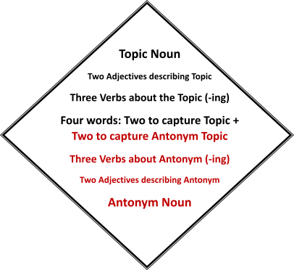 | Example of an Antonym Historic Diamante  Christopher Columbus “Dually noted”  Hero  Admirable, Adventurous  Exploring, Colonizing, Converting  Idealized Myth, Genocidal Criminal  Terrorizing, Kidnapping, Murdering  Heinous, Vile  Villain

Name________________________________ Rubric: Historic Diamante Poem

Format & Content Criteria | 1 | 2 | 3 | 4 | Feedback
Lines 1 + 7 One-word nouns/line that reflect opposing POV’s or ideas that are historically accurate.
Lines 2 + 6 Two adjectives/line that accurately describe the topics.

Lines 3 + 5 Three verbs/line ending in – ing that accurately capture the topics.
Line 4 Four words: two words referring to Line 1 + two words referring to Line 7 that accurately illustrate the topic.
Title Word choice of title hints to or reflects the opposing historical POV’s or ideas within the poem.
Total Score
18-20 points … A
16-17 points … B
14-15 points … C
12-13 points … D
0-11 points … F
1= Criteria not met 2= Criteria partially met 3= Proficient 4 = Exceeds Expectations

Name_____________________________ I Am Poem- Template

Directions: Based upon the information you learned about the Navajo Treaty of 1868 create an I Am Poem. An I Am Poem is a poem about a person, group of people, a place, or even an inanimate object. An I Am Poem does not have to rhyme and is based upon a template that focuses on emotions and senses.

For this assessment, you will write an I Am Poem from the point of view of the Navajo Treaty of 1868. This will take imagination and creativity as you will write as if the inanimate treaty is a living, breathing human. When writers give human qualities, feelings, actions, or characteristics to non-living objects, this is called personification. The I Am Poem should reflect both the gains and concessions in the treaty. The I Am Poem Template is:

Poem Title
Stanza #1
I am ___________________________________________________________________
I hear __________________________________________________________________
I see ___________________________________________________________________
I taste __________________________________________________________________
I smell _________________________________________________________________
I touch _________________________________________________________________
Stanza #2
I am ____________________________________________________________________
I wonder ________________________________________________________________
I pretend ________________________________________________________________
I feel ____________________________________________________________________
I worry __________________________________________________________________
I cry ____________________________________________________________________

I am ____________________________________________________________________
I understand _____________________________________________________________
Stanza #3
I say ____________________________________________________________________
I dream __________________________________________________________________
I try _____________________________________________________________________
I hope ___________________________________________________________________
I am _____________________________________________________________________

Example of an “I Am” Poem
The Constitution: A Reflection on My Labor and Delivery
By Jeannine Kuropatkin
I am a mutual concession born of secrecy and sweat in a Philadelphia hall
I hear impassioned arguments for the Virginia, then the New Jersey Plan
I see Sherman’s proposal resolve the issue of Congressional representation
I taste the bittersweet demise of the Articles of Confederation
I smell the ink of Madison’s pen as it glides across my parchment page
I touch the raw nerve of civility as debate teeters on the brink of compromise

I am the embodiment of Enlightenment ideas, crafted by American philosophes
I wonder how this social contract will weather the test of time
I pretend “We the People” proclaims a virtuous popular sovereignty, HOWEVER
I feel these three noble words do not ring true for all
I worry about my imperfections that enable privilege for some at the dispossession of others
I cry out, “Whose liberty? What of the inalienable rights of the enslaved, the women, and the indigenous peoples of this land?”

I am a birth certificate, midwifed by many, with 39 signatures of fatherly pride
I understand that for some, my legitimacy is questioned without a Bill of Rights
I say let this labor of love between factions play out to resolve this issue
I dream that civil discourse between Federalists and Antifederalists will rule the day
I try to keep faith in the principles of civic virtue that instilled my founding fathers
I hope this will lead to my ratification as the supreme law of the land
I am destined to be a Charter of Freedom, embedded in the hearts, minds, and aspirations of people everywhere

Name________________________________ Rubric: “I Am” Poem

Navajo Treaty of 1868
Criteria | 1 | 2 | 3 | 4 | 5 | Feedback
Stanza #1 Effective word choice that aligns with the template sensory prompts and conveys accurate historical content.
Stanza #2 Effective word choice that aligns with the template emotive prompts and conveys accurate historical content.
Stanza #3 Effective word choice that aligns with the template emotive prompts and conveys accurate historical content.
Title & Overall Message of Poem Word choice used in the title and overall poem clearly reflects BOTH the gains & concessions of the Navajo Treaty of 1868.
Total Score
18-20 points … A
16-17 points … B
14-15 points … C
12-13 points … D
0-11 points … F
1= Needs Improvement 2= Partially Proficient 3= Proficient 4 = Highly Proficient 5 = Exceeds Expectations

Teacher Resources Related to Lesson Content:
Smithsonian Institute National Museum of the American Indian (NMAI) website. https://americanindian.si.edu/
Maps from the Arizona Geographic Alliance https://geoalliance.asu.edu/
Harjo, Suzan Shown, and Jennifer Nez Denetdale. “Naal Tsoos Saní: The Navajo Treaty of 1868, Nation Building, and Self-Determination.” Essay. In Nation to Nation: Treaties Between the United States & American Indian Nations, Published by the National Museum of the American Indian in Association with Smithsonian Books, Washington DC, 2014.
Michaelis, Bernhard. The Navajo Treaty 1868: Treaty between the United States of America and the Navajo Tribe of Indians. Flagstaff, AZ: Created by Native Child Dinetah, 2014.
Denetdale, Jennifer. The Long Walk: The Forced Navajo Exile. New York: Chelsea House Publishers, 2008.
Dunbar-Ortiz, Roxanne. “Chapter 8 Indian Country.” Essay. In: An Indigenous Peoples’ History of the United States. Boston: Beacon, 2014.
Michaelis, Bernhard. The Navajo Treaty 1868: Treaty between the United States of America and the Navajo Tribe of Indians. Flagstaff, AZ: Created by Native Child Dinetah, 2014

