Lesson Title: Culture and Food Name___________________________
Explain -Discussion Checklist (Formative Assessment)
(Students Think-Pair-Share what they have learned so far in the lesson.)

Student’s Name Student’s Response to what they have learned:
Student’s Name

Vocabulary Words, Meanings, and Pictures from the book Fry Bread
Native American | a member of any of the indigenous people of the United States | 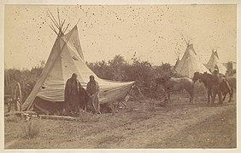  https://commons.wikimedia.org/wiki/File:-Native_American_Women_and_Horses_by_Teepee_in_Camp-_MET_DP115232.jpg
heritage | cultures, values, traditions passed down by previous family members | 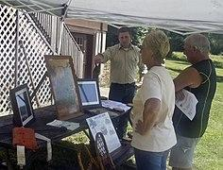  https://commons.wikimedia.org/wiki/File:Heritage_Day_at_Tionesta_(9685968865).jpg
The Long Walk | a time in 1864 when the Navajo people were forced to leave their homeland in Arizona and walk to eastern New Mexico | 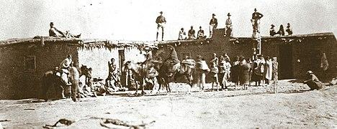  https://commons.wikimedia.org/wiki/File:Long_Walk_of_the_Navajos,_Navajo_captives_at_Fort_Sumner,_c._1860s,.jpg
recipe | a set of instructions for making some kind of food dish | 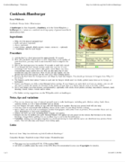  https://commons.wikimedia.org/wiki/File:Wikibooks_hamburger_recipe.png
dough | a thick mixture of flour and liquid used for baking bread | 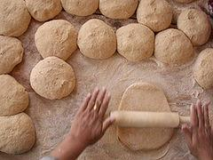  https://commons.wikimedia.org/wiki/File:Work_dough.jpg
nation | a large group of people living in a common place, having a common language and traditions | 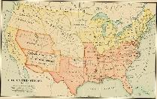  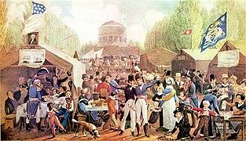  https://commons.wikimedia.org/w/index.php?search=american+nation&title=Special:MediaSearch&go=Go&type=image  https://commons.wikimedia.org/wiki/File:4th-of-July-1819-Philadelphia-John-Lewis-Krimmel.JPG

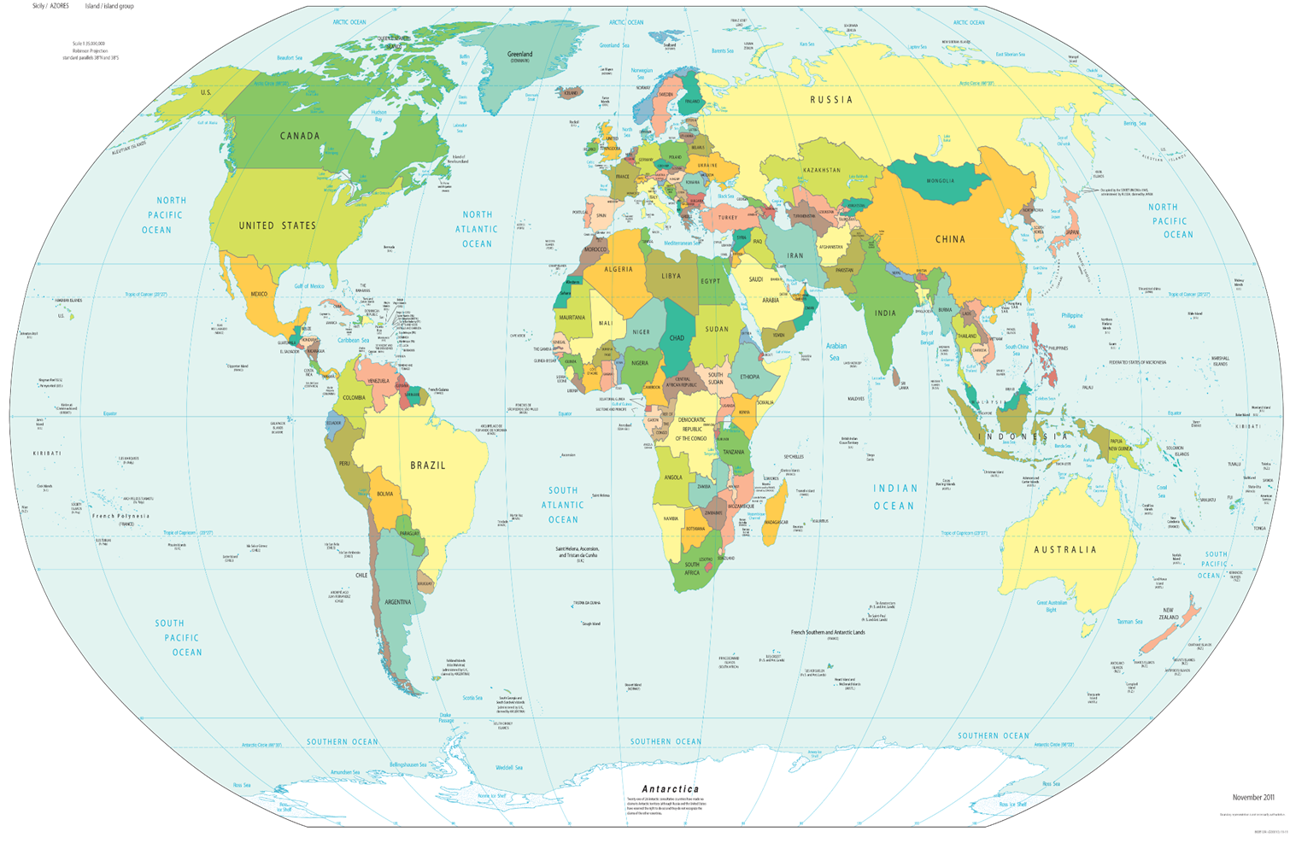

Inquiry Question: How do people, goods, and ideas move from place to place? Name: ________________
Student Research Notes:
My Own Cultural Foods and Where They Originated From
My Cultural Foods Originated From: How this Food Got to the United States
_______________________ | United States?  If NO, from  YES: where?  _______________  If NO, from  YES: where?  ______________  If NO, from  YES: where?  ______________  If NO, from  YES: where?  ______________  If NO, from  YES: where?  ______________ | If NO, how did this food get to the United States?  ____________________________
: Research Site: A Map Of Where Your Food Originated May Surprise You : The Salt : NPR

Summative Assessment Rubric for Creating a Big Book or Poster
Category | 4 | 3 | 2 | 1 | Comments
Big Book or Poster completion | Book fully complete | Book mostly complete | Book about one-half complete | Book less than one-half complete
Cultural foods with names with picture of each food item | All foods named with pictures. | Most foods are named with most pictures. | Some foods are named with some pictures. | Few foods are named; few or no pictures
Cultural connection to the food. Description of why the food is considered cultural | Complete description of cultural connections to food | Mostly complete description of cultural connections to food | Some description of cultural connections to food | Little to no description of cultural connections to food
Description of where cultural foods came from and how the foods got to the US | Complete description of where food originally came from | Mostly complete description of where food originally came from | Some description of where food originally came from | Little to no description of where food originally came from

Summative Assessment: INSTRUCTIONS for CREATING A BIG BOOK or a POSTER to Show and Describe Your Family’s Food History: OPTIONS: Create a Big Book or Create a Poster
To make a big book you will need one poster board. Fold the poster board in half like a book and insert and staple or clip some paper Inside for the pages. Then add pictures and information from your research about your family’s cultural foods.

Big Book Example:

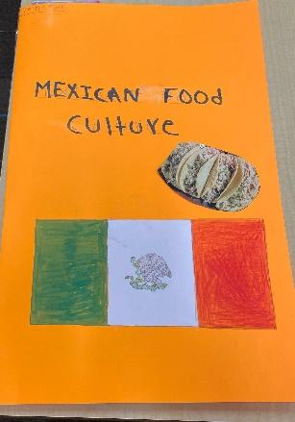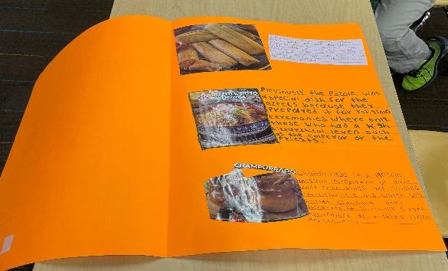
- To make a poster, use a full poster board and include the following components:
Note: You can even use two or three more poster boards if you want.

COMPONENTS to INCLUDE:

- On each page of your book or on your poster board/s add or draw pictures of your family’s cultural foods. Include names of each item. Then write down information about how this food is connected to your culture. This should explain how the food is considered a cultural food.
- Describe where the cultural food came from and how it got to the United States.
- You can put information on each page or each poster board that you found from your resource. This should show and explain what you have learned about your cultural and cultural foods.
An Example of a Cultural Food Plate:

