Map of the United States and Mexico

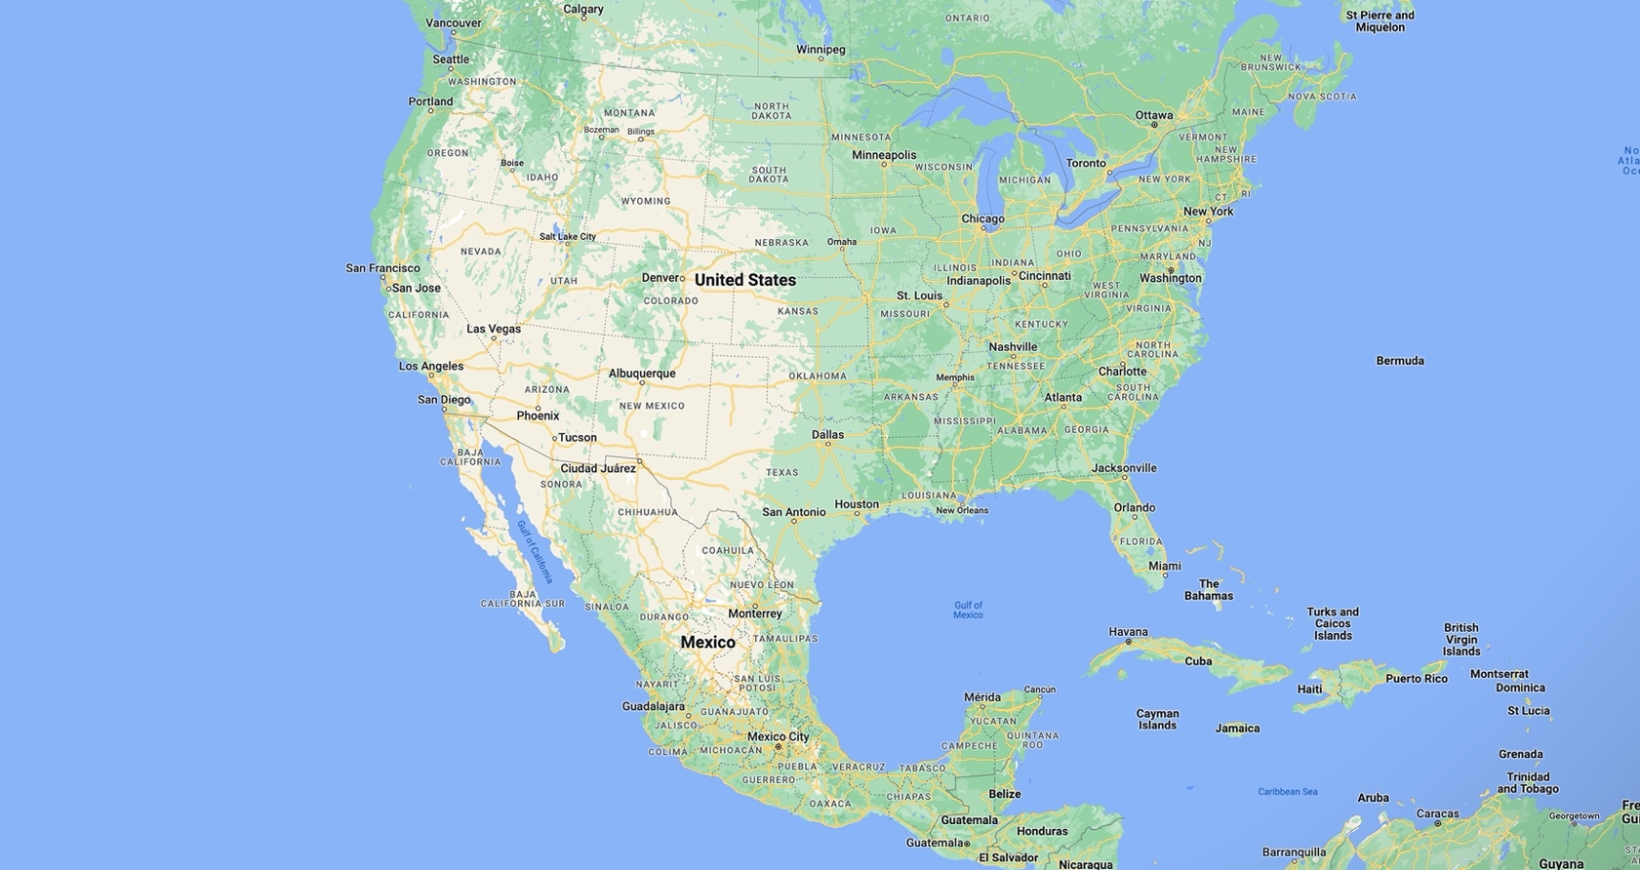
https://www.google.com/maps/place/United+States/@37.6,-95.665,4z/data=!3m1!4b1!4m6!3m5!1s0x54eab584e432360b:0x1c3bb99243deb742!8m2!3d37.09024!4d-95.712891!16zL20vMDljN3cw?entry=ttu

Map of the United States in English

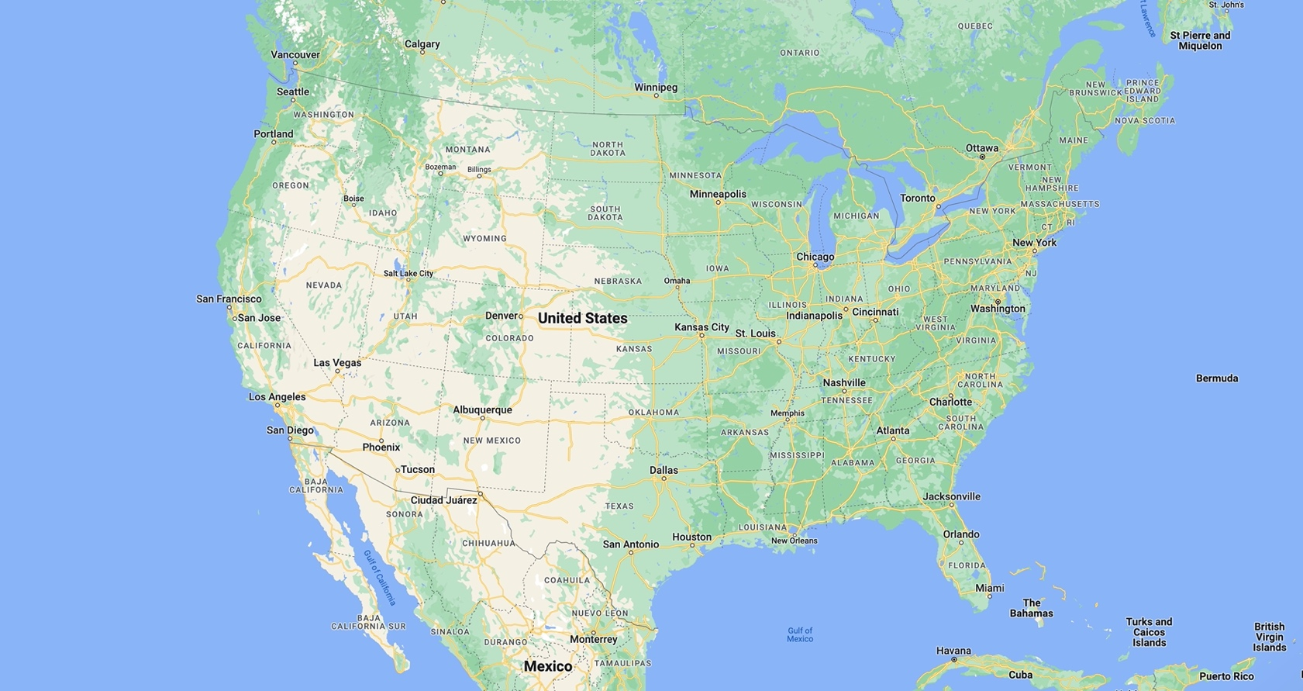

https://www.google.com/maps/place/United+States/@37.6,-95.665,4z/data=!3m1!4b1!4m6!3m5!1s0x54eab584e432360b:0x1c3bb99243deb742!8m2!3d37.09024!4d-95.712891!16zL20vMDljN3cw?entry=ttu

World Map

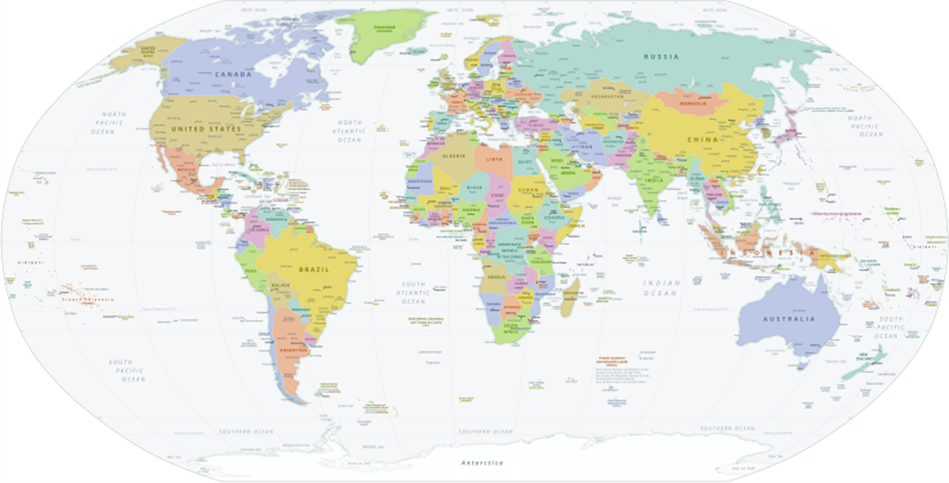

https://commons.wikimedia.org/wiki/File:World_Map_(political).svg

Esperanza Rising: Vocabulary Worksheet

Define the following words from the novel, Esperanza Rising. Include a sentence from the novel and illustrate the meaning of the word.

You will need to do this for each of the 7 words.
Word and Definition:  campesino | Sentence from the Text
Illustration

Word and Definition:  Esperanza | Sentence from the Text
Illustration

Word and Definition:  Great Depression | Sentence from the Text
Illustration

Word and Definition:  immigration | Sentence from the Text
Illustration

Word and Definition:  la cosecha | Sentence from the Text
Illustration
Word and Definition:  migration | Sentence from the Text
Illustration

Word and Definition:  renegade | Sentence from the Text
Illustration

Esperanza Rising: Vocabulary Worksheet - Answer Key

Define the following words from the novel, Esperanza Rising. Include a sentence from the novel and illustrate the meaning of the word.

You will need to do this for each of the 7 words.
Word and Definition:  campesino: Spanish word meaning “fieldworker” | Sentence from the Text  A campesino family waved to them. (p.85)
Illustration
Word and Definition:  Esperanza: Spanish word meaning “hope” | Sentence from the Text  Esperanza kept looking for them, and she became more anxious with each passing minute (p.84)
Illustration
Word and Definition:  Great Depression: The time between 1929–1939 when the United States and most countries experienced an economic shock. There was a major fall in stock prices. | Sentence from the Text  Government officials thought this would solve the unemployment associated with the Great Depression (it didn’t). (p. 258)
Illustration

Word and Definition:  immigration: The action of moving to live  permanently in a foreign country. | Sentence from the Text  The conductors herded everyone into a building where they stood in long lines waiting to pass through immigration. (p. 81)
Illustration
Word and Definition:  la cosecha: Spanish word meaning “harvest” | Sentence from the Text  “¡La cosecha!” said Papa. “Harvest!” (p.6)
Illustration
Word and Definition:  migration: Some people move in search of work or economic opportunities, to join family, or to study. Some people might migrate to escape conflict, persecution, terrorism, or human rights violations. | Sentence from the Text  It was the largest involuntary migration in the United States up to that time. Between 1929 and 1935 at least 450,000 Mexicans and Mexican Americans were sent back to Mexico. (p. 258)
Illustration

Word and Definition:  renegade: Someone who rebels. | Sentence from the Text  They were renegades who thought they had permission to steal from the rich and give to the poor. (p.61)
Illustration

HORIZONTAL BLANK TIMELINE TEMPLATE

Title:

HORIZONTAL BLANK TIMELINE TEMPLATE - ANSWER KEY
Title: Esperanza Rising
Chapter 1
Aguascalientes, Mexico 1924
Papa helped Esperanza feel the heartbeat of the earth.
Chapter 2: Las Uvas
Esperanza’s father was killed by bandits the day before her birthday.

Chapter 7: Las Cebollas
Esperanza is learning how to take care of the baby and clean the hours.

Chapter 5: Las Guayabas
Esperanza travels to the Mexican border.

Chapter 12: Los Espárragos
The strike begins and it takes a toll the farm workers. The workers are also being abused verbally.

Chapter 14: Las Uvas
Miguel brings Abuelita home.
Chapter 9: Las Ciruelas
There is a dust storm and Mama becomes sick with Valley Fever.

Esperanza Rising Summary of Learning Assessment Rubric
Criteria Points
Exceeds Expectations | Discusses 3 or more points about what was learned and tells how you connected to the story and includes references to specific chapters in the book. Examples from the novel are used to support your ideas and explanations are detailed . | 90-100
Meets Expectations | Discusses 3 or more points about what was learned and tells how you connected to the story and includes references to specific chapters of the book. Some examples from the novel are used to support your ideas and explanations provide some details. | 80-89
Approaches Expectations | Discusses only 2 points about what was learned and tells how you connected to the story. Ideas are briefly supported by the novel with only a few details provided. | 70-79
Fails to Meet Expectations | Discusses only 1 point about what was learned and tells little to nothing about connections made to the story. Ideas are not supported by the novel. | below 69

The students will be expected to reference specific chapters that resonated with them the most.
a. The students must use examples from the novel to support their ideas.

Additional Resources for Esperanza Rising

Reading by author of Esperanza Rising:
https://www.teachingbooks.net/book_reading.cgi?a=1&id=12420

United States Google Map in English:
https://www.google.com/maps/place/United+States/@37.6,-95.665,4z/data=!3m1!4b1!4m6!3m5!1s0x54eab584e432360b:0x1c3bb99243deb742!8m2!3d37.09024!4d-95.712891!16zL20vMDljN3cw?entry=ttu

Map of the US and Mexico:
https://www.google.com/maps/place/United+States/@37.6,-95.665,4z/data=!3m1!4b1!4m6!3m5!1s0x54eab584e432360b:0x1c3bb99243deb742!8m2!3d37.09024!4d-95.712891!16zL20vMDljN3cw?entry=ttu

Author Website:
https://www.pammunozryan.com/esperanza-rising/

Reading by Author:
https://www.teachingbooks.net/book_reading.cgi?a=1&id=12420

Theater Script:
https://www.pammunozryan.com/wp-content/uploads/2015/06/scriptEsperanza.pdf

Bloom's Taxonomy:
https://innovativeteachingideas.com/blog/a-teachers-guide-to-blooms-taxonomy

Wakelet Resources:
https://wakelet.com/wake/v8mhxsjMs1ycn6aNBavrt
https://wakelet.com/wake/_2z2DwKM4wcrzlgwWJTSL

Chapter Summaries:
https://www.shmoop.com/study-guides/literature/esperanza-rising/summary/chapter-1

