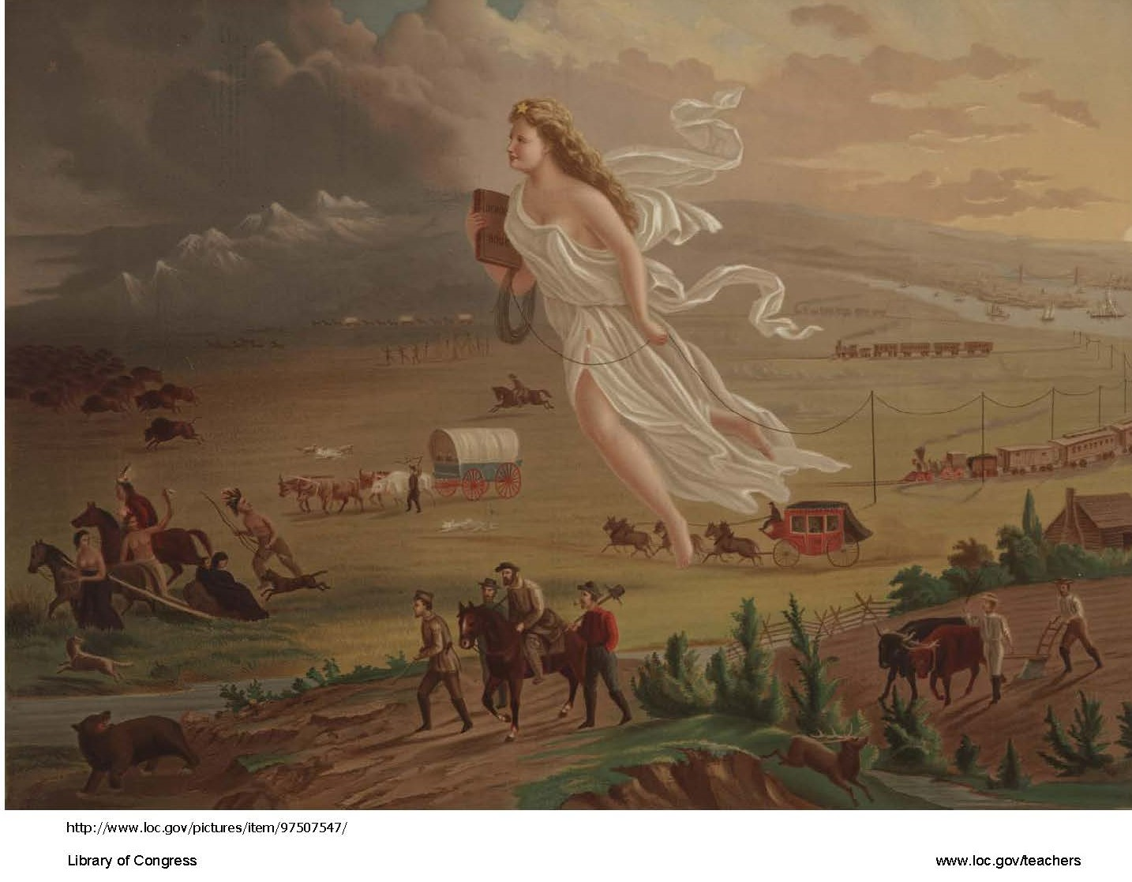
Placemat Consensus Handout
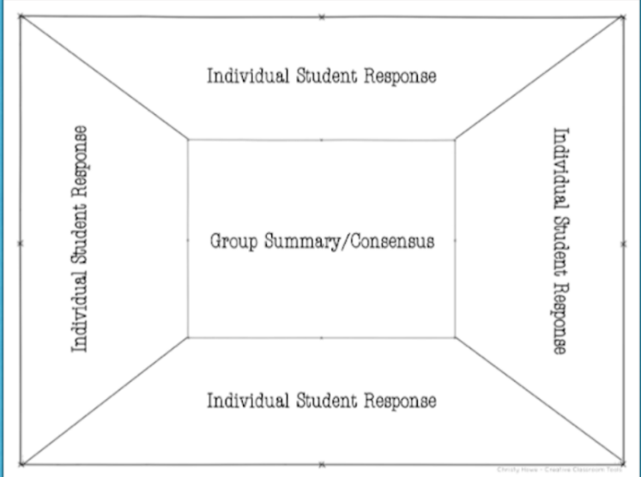
Manifest Destiny Map and Handout
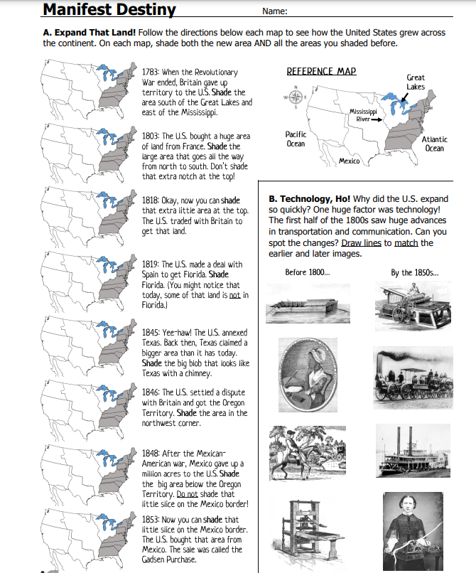
Manifest Destiny Map and Handout - ANSWER KEY
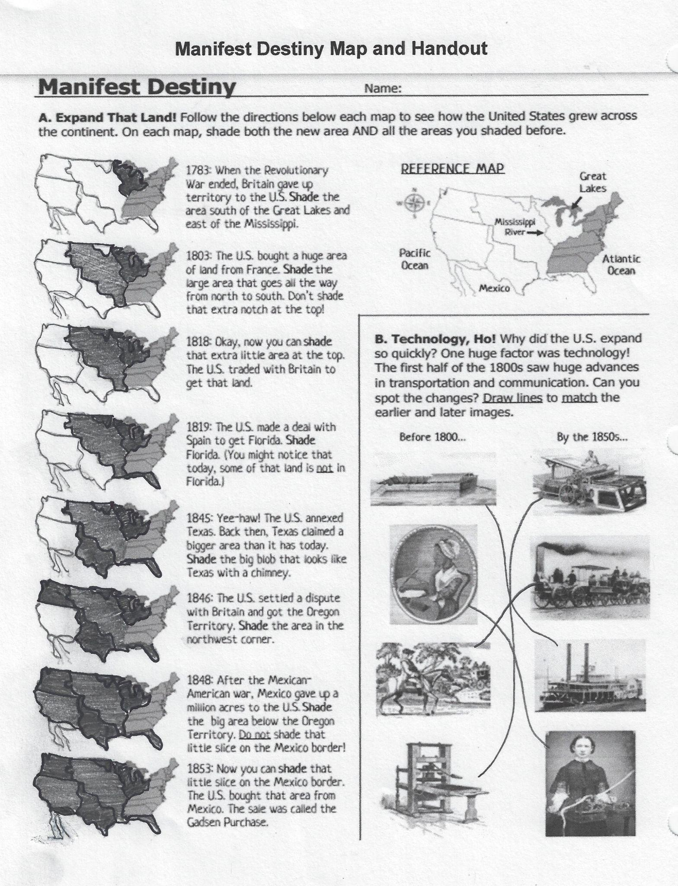

Story Pyramid Handout
https://www.teachstemss.com/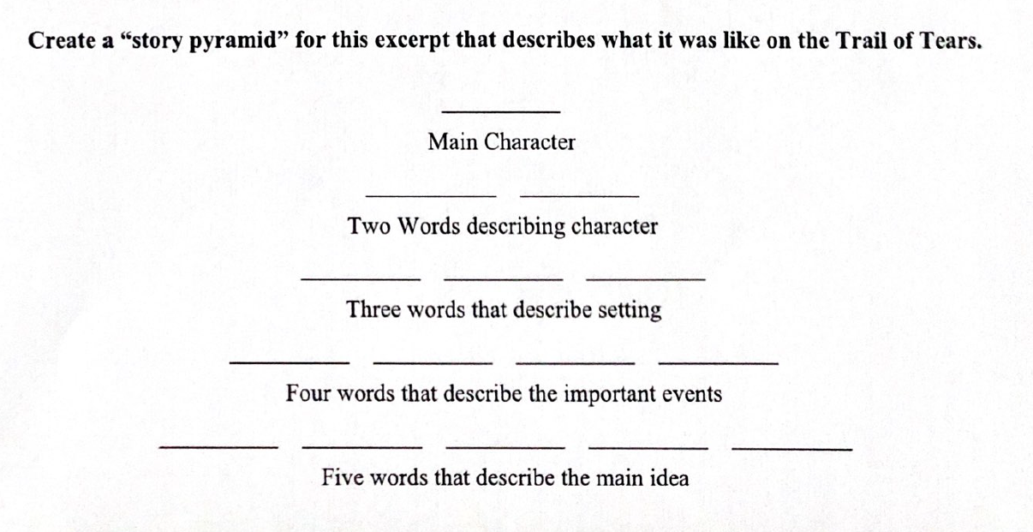

Story Pyramid Sample ANSWER KEY - (Note: Words Selected by Students May Vary

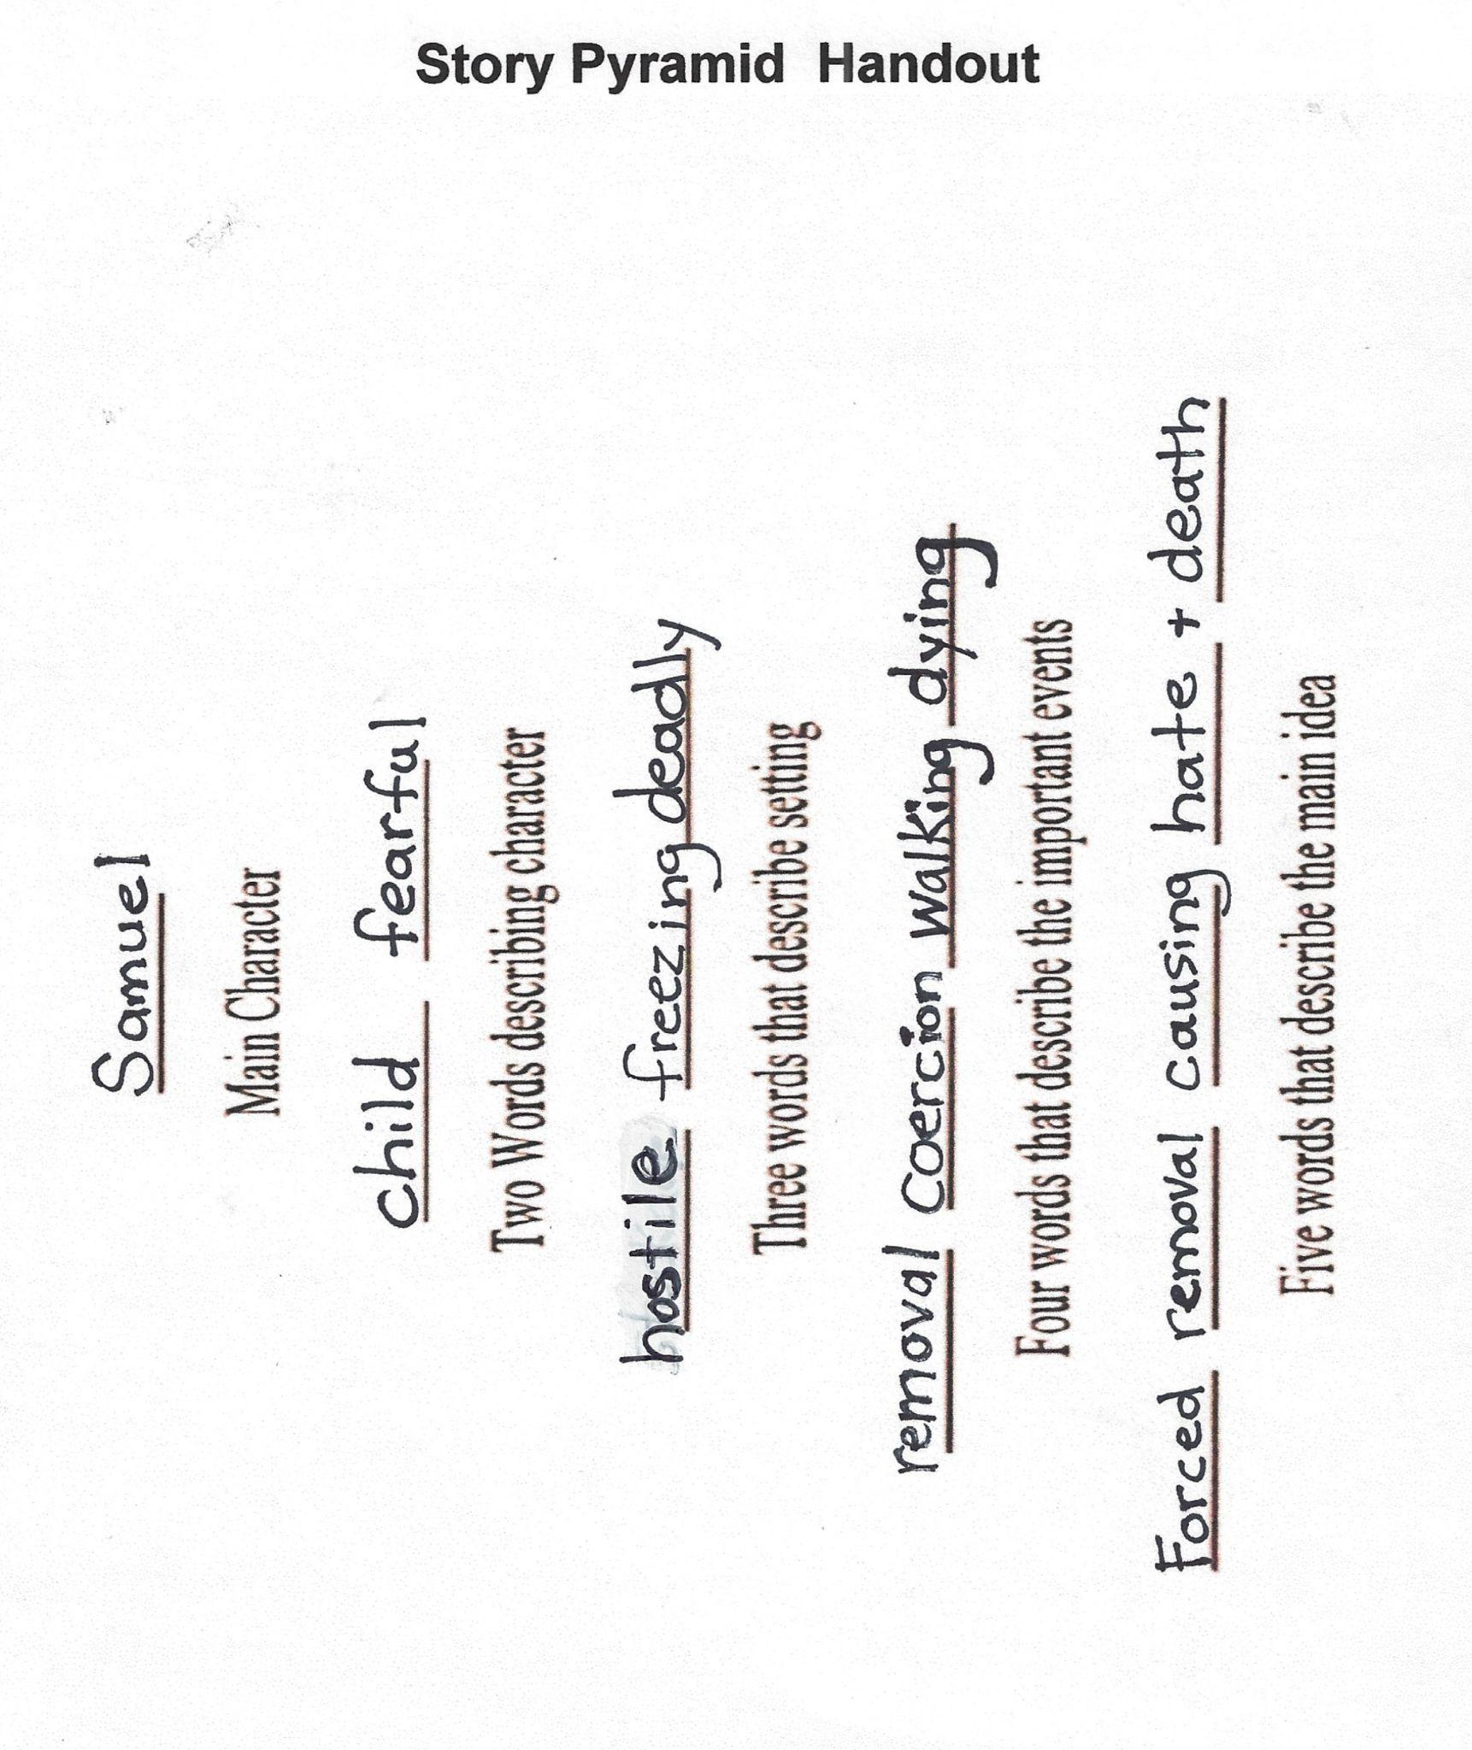

Story Pyramid Rubric

 | Poor-0 | Fair-1 | Good-3 | Excellent-4
Character & Character Description | Didn't identify the main character | Listed the main character but gave no description. | The main character is listed and described. | The main character is listed and described with excellent clarity and detail.
Setting | Didn't identify the setting. | Listed the setting but gave no description. | The setting is listed and includes some accurate description. | The setting is listed and described with excellent clarity and detail.
Events | Didn't identify the main events of the story. | Listed main events but gave no description. | Main events are listed and accurately described. | Main events are listed and described with excellent clarity and detail.
Main Idea | Didn't identify the main idea. | Listed the main idea (resolution) but gave no description of it. | The main idea is listed and accurately described. | The main Idea is listed and described with excellent clarity and detail.

