I Have, Who Has? Vocabulary Cards (Please cut before teaching the lesson)
I have  the first card  Who has  latitude  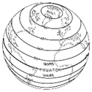 | I have  latitude  Who has  longitude | I have  longitude  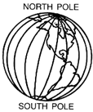  Who has  tribal nations
I have  tribal nations  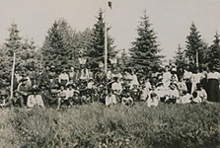  Who has  colonialism | I have  Colonialism  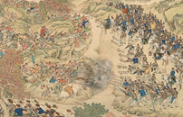  Who has  land  acknowledgement  statement | I have  land  acknowledgement  statement  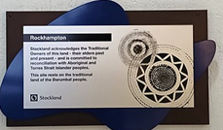  Who has  indigenous
I have  indigenous  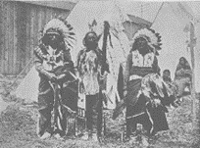  Who has  interaction | I have  interaction  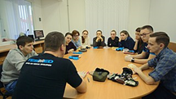  Who has modification | I have  modification  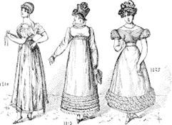  Who has  inhabit

I have
inhabit
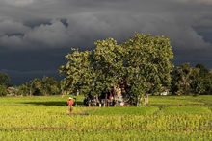
I have
the last card

Indigenous People Graphic Organizers for Research

Name: _______________________________ My zip code: ________________________

The tribe whose land I am living on: ___________________________________________

Is the tribe one of the 22 federally recognized tribes in Arizona? ____ Yes _____ No

Where is the tribe located today? ______________________________________________

3 things learned about this tribe:

__________________________  __________________________  __________________________  __________________________  __________________________  __________________________  __________________________  __________________________ | __________________________  __________________________  __________________________  __________________________  __________________________  __________________________  __________________________  __________________________ | __________________________  __________________________  __________________________  __________________________  __________________________  __________________________  __________________________  __________________________

Formative Assessment Checklist

Students’ response to: (1) Inquiry Question #1-“Who were the first people to inhabit these lands we reside on in Arizona?” (2) The name of the tribe whose land they live on, (3) Is the tribe a federally recognized tribe in AZ (4) Where the tribe is located today (5) 3 other things learned about the tribe.
Name: ________________ | Name: ________________ | Name: ________________ | Name: ________________ | Name: ________________
Name: ________________ | Name: ________________ | Name: ________________ | Name: ________________ | Name: ________________
Name: ________________ | Name: ________________ | Name: ________________ | Name: ________________ | Name: ________________
Name: ________________ | Name: ________________ | Name: ________________ | Name: ________________ | Name: ________________
Name: ________________ | Name: ________________ | Name: ________________ | Name: ________________ | Name: ________________

Identifying Indigenous Lands Graphic Organizer
Directions: Using your computer and the websites you have learned to use in class, find the latitude and longitude of the location of the zip code you were given and find out what Indigenous people had lived in this place in the past. Record on the chart below.

ZIP CODE: _________________

Latitude: __________________ and Longitude: ________________________ of this zip code.

The name of the Indigenous People who lived on and owned this land in the past: _____________________________________________

Describe what you have learned about this Indigenous People group’s life and culture and history:

_______________________________________________________________________________________________________________

________________________________________________________________________________________________________________

________________________________________________________________________________________________________________

________________________________________________________________________________________________________________

________________________________________________________________________________________________________________

________________________________________________________________________________________________________________

_________________________________________________________________________________________________________________

________________________________________________________________________________________________________________

________________________________________________________________________________________________________________

________________________________________________________________________________________________________________

________________________________________________________________________________________________________________

________________________________________________________________________________________________________________

________________________________________________________________________________________________________________

________________________________________________________________________________________________________________

________________________________________________________________________________________________________________

________________________________________________________________________________________________________________

________________________________________________________________________________________________________________

________________________________________________________________________________________________________________

________________________________________________________________________________________________________________

________________________________________________________________________________________________________________

Identifying Indigenous Lands Graphic Organizer- RUBRIC

CRITERIA PT VALUES
Exceeds Expectations | The Graphic Organizer identifies the correct latitude and longitude of the given zip code location and it also includes information about what this area is called today. It accurately names the Indigenous People group or groups who lived and owned the land in this zip code location in the past. It provides 5 or more full statements written in complete sentences that gives accurate and detailed information about the Indigenous People groups who lived here telling how they lived their lives and describing many aspects of their culture and providing a full and detailed narrative about the history of this group including what happened to them and where they are today. | 28 + pts.
Meet  Expectations | The Graphic Organizer identifies the correct latitude and longitude of the given zip code location. It names the correct Indigenous People who lived and owned the land in this zip code location in the past. It provides at least 3 full statements with accurate and detailed information about the Indigenous People group’s ways of life, aspects of their culture, and provides some information about the history of this group. | 18 to 27  pts.
Approaches Expectations | The Graphic Organizer is partially completed giving information about the latitude and longitude of the given zip code and accurately naming the Indigenous People who lived and owned the land in this location. It gives at least 2 statements providing some accurate but vague and/or unclear information about the Indigenous People group’s life and/or culture and/or history. | 12 to 17  pts.
Fails to Meet Expectations | The Graphic Organizer is incomplete and/or provides inaccurate information about the latitude and longitude of the zip code area and the Indigenous People who lived in this zip code location in the past. It also lacks accurate and complete information about the people’s life, culture, and history. | 0 to 11 pts.

Teacher Resource: Using Zip Codes to locate Arizona’s Native Indian Tribes:

- 85138=Ak-Chin Indian Community
In the area of 85138 you are on O’odham Jeweḍ, Akimel O’odham (Upper Pima), and Hohokam land.
- 85350=Cocopah Indian Tribe
In the area of 85350 you are on Xawiƚƚ kwñchawaay (Cocopah) and Quechan (Kwatsáan) land.
- 85328=Colorado River Indian Tribes
In the area of 85328 you are on Xawiƚƚ kwñchawaay (Cocopah), Quechan (Kwatsáan), and Yavapai Apache land.
- 85269=Fort McDowell Yavapai Nation
In the area of 85269 you are on O’odham Jeweḍ, Akimel O’odham (Upper Pima), and Hohokam land.
- 86401 Fort Mojave Indian Tribe
In the area of 86401 you are on Hualapai land.

