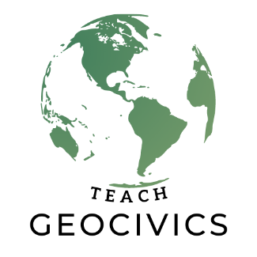
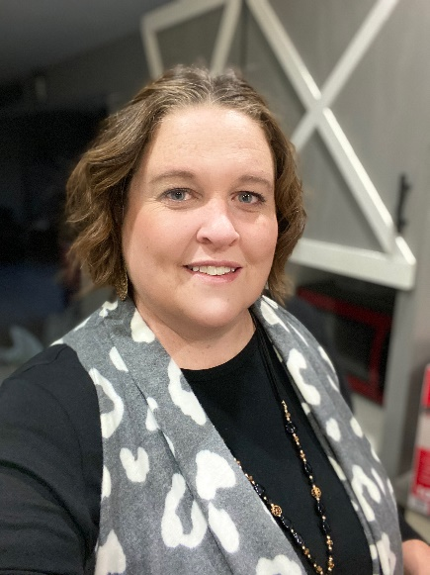
New Mexico…
Heather Holguin
Heather Holguin holds a Bachelor’s of Science in Elementary Education, a Master’s degree in Teaching and has recently obtained her PreK-12 Administrative License for the state of NM. She has taught elementary classes the past 18 years. Shes has taught all grades except 3rd and have enjoyed them all. Her favorite part of teaching young learners is teaching them to read because reading opens the opportunities for students to go on so many adventures through text. Another one of her passions is to learn and teach about the people that came before us and set pathways for our lives today. To have this opportunity to learn about the Westward Expansion and how it impacted the Native Americans along with the pioneers. I will be excited to take the information I’ve learned and pass it in to my students for years to come! Her goals in education is to someday teach at the college level and better prepare future educators in the area of literacy.
Heather lives in Cliff, NM with her husband, Daryl and 17 year old daughter, Hannah. As a family, they enjoy going on outdoor adventures, such as going on side-by-side rides, hunting, fishing, hiking and camping. They also enjoy traveling and visiting historical landmarks.
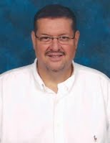
Juan Armijo
Juan Armijo is currently a social studies teacher at Mayfield High School in Las Cruces, New Mexico and previously was a social studies teacher at Camelback High School in Phoenix, Arizona. He is a graduate of New Mexico State University and Arizona State University and has completed programs for education endorsements at Lamar University and the University of Kentucky. At Mayfield High School he is a member of the leadership team and social studies department head, the district level (Las Cruces Public Schools) has served on social studies curriculum and textbook adoption teams. At the state level Juan has been involved in Social Studies End of Course Exam teams, AP Conference Presenter, on the team that wrote the newly developed New Mexico Social Studies Standards and the Instructional Scope.
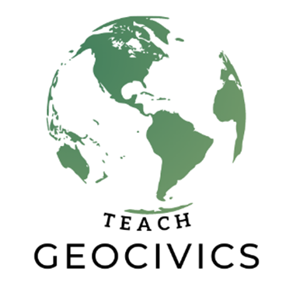

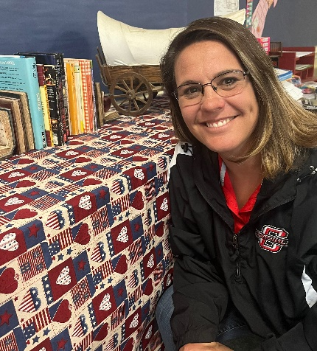
Jewell Burns
Jewell Eva Burns holds a Bachelor's of Science in Elementary Education and is currently working on her Master's degree in the Teaching of Reading. She has been teaching for 22 years. She has taught grades Kindergarten through 6th grade. Her current position is teaching 3rd-grade teacher at Cliff Elementary, she is also the assistant varsity girls basketball coach, and track coach. She teaches reading, writing, math, geography, history, science, and social-emotional growth. Mrs. Burns has a passion for teaching reading to students as well as the History of the United States through hands-on activities. She is excited to have this opportunity and be able to share the knowledge that she gains with her students and colleagues.
Jewell Eva Burns lives in the Burro Mountains of Southwest New Mexico with her husband, Shad. They have four grown children and three grandchildren who are scattered throughout New Mexico and Oklahoma. They enjoy spending time with their family, hunting, fishing, golfing, and working on their property in Reserve NM.

